


Moorfields Eye Hospital NHS Foundation Trust Annual Report and Accounts 2025/26

Presented to Parliament pursuant to Schedule 7, paragraph 25(4)(a) of the National Health Service Act 2006.

Contents
1
1. Welcome from the chair and chief executive 4
2. Performance report 5
2.1 Overview of the trust 5
2.2 Strategic objectives & priorities 5
2.2.1 Strategic objectives 5
2.2.2 Strategic context 6
2.2.3 Performance 6
2.2.4 Key strategic achievements 6
2.3 Business model and operating context 7
2.3.1 Business context 7
2.3.2 How we are structured 8
2.3.3 Moorfields Private and International 8
2.4 Performance overview 9
2.4.1 Annual performance statement from chief executive 9
2.4.2 Performance analysis 2025/26 10
2.4.3 Green Plan progress 13
2.4.4 Social contribution 14
2.5 Quality and patient safety 14
2.5.1 Quality priorities 14
2.5.2 Health inequalities 15
2.6 Workforce overview 16
2.6.1 Staff report 16
2.6.2 Staff Survey 18
2.7 Financial performance (narrative) 21
2.8 Sustainability 26
3. Accountability report 29
3.1 Directors’ Report 29
3.1.1 NHS Oversight Framework disclosure 30
3.1.2 Taskforce on climate-related financial disclosures 31
3.1.3 Going concern disclosure 31
3.1.4 Statement of accounting officer’s responsibilities 32
3.1.5 Directors’ report, additional detail 32
3.1.6 Modern Slavery statement 35
3.2 Members’ Report 37
3.2.1 Membership report 37
3.2.2 Membership Council composition and attendance report 2025/26 38
3.3 NHS Provider Code of Governance 41
3.4 Annual Governance Statement (AGS) 42
3.4.1 Scope of responsibility 42
3.4.2 The purpose of the system of internal control 43
3.4.3 Capacity to handle risk 43
3.4.4 The risk and control framework 44
3.4.5 England’s well-led framework 47
3.4.6 Governance, assurance, and internal control 47
3.4.7 Review of economy, efficiency and effectiveness of the use of resources 49
3.4.8 Workforce 50
3.4.9 Register of interests 50
3.4.10 Information governance 50
3.4.11 Data quality and governance 50
3.4.12 Review of effectiveness 50
3.4.13 Conclusion 51
3.5 Remuneration Report 51
3.6 Exit packages disclosure 62

Welcome from the chair and chief executive
As we look back on 2025/26, we can reflect it has been a year of real change and great achievements for Moorfields.

Change is rarely easy, but our staff have remained resilient, committed, and focused on delivering world-class care. Their dedication has been instrumental in advancing key transformation projects that will futureproof Moorfields and ensure we remain at the forefront of world leading eye care.

It is also because of everyone’s dedication and hard work that we have delivered a financial surplus this year and we have seen reductions in our elective waiting lists.

The building of our new state-of-the-art eye care, research and education centre in partnership with Moorfields Eye Charity and the Institute of Ophthalmology in Camden, progresses well and is being made ready to open in 2027.

We have also moved forward with our new electronic patient record known as MoorConnect. We are on track to complete implementation by the end of 2026. Our digital transformation also took a major step forward. Our Single Point of Access service across North Central London, Sparc, launched last year and has seen an improvement to patient choice, and streamlining the management of optometry-led pathways, low vision services, and referral management.

Moorfields Private continues to deliver exceptional diagnostic, outpatient, and inpatient care services from world-leading consultants and nursing teams in City Road and New Cavendish Street in the heart of London’s medical district.

Our units in Dubai and Abu Dhabi continue to provide services to an international market. We have been in close and regular contact with our teams in the middle east as the tensions in the area intensified over the course of the year and will continue to support staff across the whole organisation who have been affected by the current geopolitical climate.

At Moorfields, every member of staff counts, and we continue to listen to our people and take their feedback on board as we move forward as an organisation.

We know that none of these achievements would be possible without our staff who continue to show their dedication and professionalism on a daily basis, and we thank them for this and their continued contribution.

We would also like to extend our gratitude to our governors and board non-executive directors for their continued support and expertise.

Professor Tim Briggs Mr Peter Ridley
interim Chair chief executive

Performance report

2.1 Overview of the trust

Moorfields Eye Hospital NHS Foundation Trust is a specialist provider of ophthalmic care, delivering diagnosis, treatment and surgery for a wide range of eye conditions. We serve local, regional, national and international patients through our main hospital in London and an extensive network of network sites across London, the Southeast, and Hertfordshire and Bedfordshire. As a tertiary referral centre, Moorfields provides highly specialised services alongside urgent and routine care. The Trust also plays a leading role in research, education and innovation, working closely with academic and industry partners within the NHS and the wider life sciences sector.

We are the leading provider of eye health care services in the UK and a world-class centre of excellence for ophthalmic research and education. Our reputation for providing the highest quality of ophthalmic care has developed over more than 200 years.

Moorfields Eye Hospital is authorised to operate as a public benefit corporation under the National Health Service Act 2006. We were in the first group of ten selected trusts to become an NHS foundation trust in 2004. We are registered without conditions and with an overall rating of ‘Good’ with the Care Quality Commission (CQC).

At the very heart of our strategy is our core belief that people’s sight matters.

2.2 Strategic objectives & priorities

2.2.1 Strategic objectives
The Trust’s strategy 2022 to 2027 is extant and good progress has been made towards realising the objectives. Our purpose as set out in our strategy is:
Working together to discover, develop and deliver excellent eye care, sustainably and at scale.

We have five strategic objectives, and these are:
- Working together means we collaborate with one another as individuals, in our teams, with our patients and our partners
- Discover means we will focus on setting the agenda, pioneering new pathways and treatments
- Develop means we will apply our discoveries and global best practice to benefit our patients, staff and the services we provide
- Deliver means we will consistently provide an excellent, globally leading service
- Sustainably means we will use our resources responsibly, safeguarding what we have for the next generation
- At scale means we will design our services so that more people can access excellent care

The full strategy can be found here Our Strategy 2022-27

2.2.2 Strategic context
Moorfields Eye Hospital operates from 20 physical sites and provides a growing number of virtual / remote digital services. For the period 2025-6 the trust locations spanned 6 ICB areas (North Central London; North East London; North West London; South West London; Bedford, Luton and Milton Keynes; and Hertfordshire and West Essex). With the recent mergers this will reduce to four (West and North London; North East London; South London cluster; Central East).

Our “home” ICB is North Central London. Here we have lead provider status, convening an NCL Ophthalmology Board and related machinery to review system performance and bring together primary care, secondary care and the independent sector. In our other ICB footprints we participate in similar collaborative efforts – the Clinical Reference Group in NWL, a co-ordinating role in SWL and a collaborative approach in NEL.

In the period 2025-26 we implemented a revised medical leadership structure, which, amongst other things, provides ICB-linked senior clinicians to participate in ICS discussions and advance local system priorities. Our deputy medical director also held a role as London ophthalmology clinical director, bringing together all ICS eye care stakeholders.

2.2.3 Performance
NCL has established a population health outcomes framework and our main role as lead provider for ophthalmology has been working to support a reduction in waiting times, so that our residents can age well and have timely access to care. This has been aided by the further roll out and development of the NCL single point of access (Sparc) run in partnership with the Royal Free London NHS Foundation Trust.

Our executive team participate in system discussions, whether clinical, operational or financial. We have played our part in achieving a balanced budget and have also supported other providers in London by offering mutual aid and the transfer of patients with long wait times for treatment at Moorfields.

2.2.4 Key strategic achievements
Our key strategic achievements in the year were:
- Progressed Oriel (the project name of the new hospital and research facility at St Pancras) and wider estate transformation
- Delivered a financial surplus and improved elective performance
- Accelerated digital transformation (Electronic Patient Record, Single Point of Access, NHS App)
- Advanced our service model redesign toward high-volume and community care
- Sustained world-leading research and AI leadership through the Global RETFound AI programme)
- Expanded our international reputation (UAE excellence accreditation)
- Maintained strong focus on quality, safety, and patient access

2.3 Business model and operating context

2.3.1 Business context
As part of the North Central London (NCL) Integrated Care System (ICS) there are responsibility for planning, coordinating and commissioning health and care services in its five boroughs, deciding how the NHS budget in NCL is spent. During the year NCL and North West London ICB progressed plans to merge their organisations into a single ICB from 1 April 2026. The focus for the Integrated Care System is on providing care and support that improves the health and wellbeing of everyone living in their borough. We have been working productively through the ophthalmology clinical network, together with other eye units in the area, to take forward important programmes of work, particularly in respect of a single point of access, as part of advancing implementation of an improved eye care pathway.

As a specialist trust delivering services from 20 sites, we are playing an active part in delivering services that meet these key aims across a number of ICSs.

Together with the ongoing support of Moorfields Eye Charity, UCL Institute of Ophthalmology (IoO), National Institute of Health and Care Research (NIHR), and other strategic partners, we conduct world-leading research and play a leading role in the training and education of eye care clinicians.

We have a unique patient case mix and more detail on our services can be found at https://www.moorfields.nhs.uk/listing/services

We deliver leading edge, life-changing research for patients with eye disease, to benefit local, national and international patient populations. The Moorfields-UCL partnership was successful in a highly competitive national competition, obtaining 5-year funding from the National Institute for Health Research (NIHR) as a designated National Biomedical Research Centre, and the only national centre in ophthalmology. The funding will be coming up for renewal in the coming year. We have also been successful in obtaining five-year NIHR funding for our Clinical Research Facility.

This infrastructure, together with grants including from Moorfields Eye Charity, has supported most of our major innovative research initiatives, enabling us to fast-track projects to benefit patients more quickly.

We are also developing better systems such as ROAM (Research Opportunities at Moorfields) to make our clinical trials available to more patients, particularly those in underserved communities.

Our researchers at Moorfields and UCL represent the largest number from a single site worldwide on The Ophthalmologist’s Global Power list.

We also continue to play a leading role in the training and education of eye care clinicians and scientists nationally and internationally, integrating with strategic partners.
We are a founding member of UCL Partners, one of the UK’s first academic health science centres.

2.3.2 How we are structured
We are led by a board of directors, which is established under the trust constitution as a unitary board.

The responsibilities of the board and the membership council are set out in our constitution, which can be downloaded from our website. They are summarised as:

Membership council:
- To hold the non-executive directors to account individually and collectively for the performance of the board of directors
- To represent the interests of the members of the trust as a whole and the interests of the public
- To give the views of the members and membership council to directors for consideration in the preparation and approval of the annual plan
- To respond when consulted by the board of directors

Board of directors:
- To hold overall accountability for the organisation and responsibility for strategic direction and the high-level allocation of resources
- To govern effectively in order to meet its responsibilities to stakeholders, including patients, staff, the community and system partners
- To ensure that there is a balance between its three key roles, to formulate strategy, ensure accountability and shape culture

We have strong clinical leadership arrangements below board level, with operational divisions each led by a clinical divisional director, and service directors for each of our clinical services.

The divisions and services are complemented and supported by corporate directorates covering operations, nursing and allied health professions, strategy and partnerships, finance, people and organisational development, research and development, IT, communications, estates, and governance. During the year medical leadership was strengthened with the introduction of medical directors to lead on different areas such as quality and safety.

2.3.3 Moorfields Private and International
Moorfields Private provides private patient services to both national and international patients. In doing so, Moorfields Private and international generates a financial contribution, which is re-invested in the delivery and development of NHS services.

Our sites offer outpatient consultations and diagnostic tests, minor procedures, ophthalmic surgery and refractive laser eye surgery. More complex surgery and the treatment of children is carried out at our City Road site.

Moorfields Private invests time and resources in building relationships with optometrists, private GPs and International Health Offices, recognising them as key partners in the referral and treatment of patients. Educational talks given by our consultants are a key element of this strategy. Our marketing team also creates further awareness of the services on offer across all sites to both referrers and patients.

The year saw the eighteenth year of operations in Moorfields Eye Hospital Dubai and the completion of eight years of operations in Moorfields Eye Hospital Centre in Abu Dhabi.

2.4 Performance overview

2.4.1 Annual performance statement from chief executive

The continuing provision of safe and effective services for patients underpins everything we do. We strive to maintain high levels of patient feedback to inform the continuous improvement of our services.

Our outcomes and safety record remain very good, with ophthalmic clinical outcomes evidenced amongst the best in the world. Once again, our care delivery has excelled and in 2025/26 we had no cases of MRSA or Clostridium difficile.

Our national friends and family test stated that the overwhelming majority of respondents would recommend us to their friends and family, with positive scores of 92%, 94% and 96% in our A&E, outpatient and admitted environments, respectively.

We had 779,374 patient contacts across our sites (excluding Bedford) which is a decrease of 3,289 (0.4%) compared with 2024/25. We had 74,259 A&E attendances, which was a year-on-year increase of 4.6%. In our outpatient settings, we also continued to provide telephone and telemedicine appointments, with 46,562 outpatient appointments held in a virtual setting.

We continued to maintain many of our key targets in 2025/26, including the delivery of all national cancer waiting time targets, 97.3% of A&E patients being admitted, transferred or discharged within four hours, and diagnostic waiting times at 99.2% within 6 weeks. We are still in the process of recovering our referral to treatment performance (85.0%), a notable achievement as we continue to assist other trusts with their longer-waiting ophthalmic patients.

Patient activity
Moorfields’ NHS patient activity and the total volume of Moorfields’ NHS activity in 2025/26 are shown in the table below, with the previous two financial years shown for comparison (these figures exclude Bedford; in Bedford we provide services on behalf of the local trust and as a result the associated activity is recorded by the local trust).

 | Activity Total
Point of delivery | 2023/24 | 2024/25 | 2025/26
A&E | 72,653 | 70,939 | 74,259
Inpatient day case | 36,592 | 36,804 | 35,273
Inpatient elective planned) | 931 | 854 | 860
Inpatient non-elective unplanned) | 2,453 | 2,580 | 2,974
Outpatient | 635,387 | 671,486 | 666,008
Grand total | 748,016 | 782,663 | 779,374

It is worth noting that 18.7% of patients treated were non-London based.

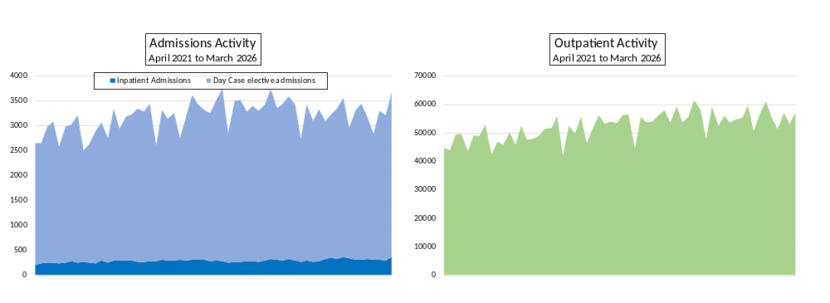

2.4.2 Performance analysis 2025/26
The Integrated Performance Report (IPR) provides the board with in-depth information on the performance of Moorfields. Each month, the performance and information department report on the following areas:

- Operational measures such as A&E figures, attendance rates and waiting times
- Workforce measures such as staff sickness rates
- Quality and safety measures such as rates of infection, patient satisfaction and incidents
- Research and development measures such as number of patients participating in research studies
- Finance measures such as variance from financial plan; and
- Commercial and private patient measures

The IPR has adopted a Statistical Process Control (SPC) data analysis and presentation methodology promoted by NHS England. This method of reviewing organisational performance moves away from the previous Red/Amber/Green rating system in favour of a more scientific interpretation of performance progression over a representative time period.

This format enables the trust to understand when significant variations in performance occur which in turn supports both a more focused and targeted response to performance improvement and a deeper understanding of any underlying factors. Importantly, it also allows the Trust to recognise and celebrate the achievement of strong levels of performance.

Training and awareness raising has been undertaken with the executive team, Board members and members of staff to ensure the reporting format is understood and capable of being cascaded across the wider organisation. Feedback on this technique has been extremely positive, and copies of the Integrated Performance Reports are available on the trust’s intranet within board papers.

18-weeks referral to treatment (RTT) standard
Indicator | Target | 2023/24 | 2024/25 | 2025/26
18-weeks RTT incomplete – all pathways | ≥ 92% | 82.1% | 83.1% | 85.6*%
18-weeks RTT incomplete – pathways with a decision to admit | n/a | 71.3% | 78.9% | 79.1*%
New RTT periods all patients | n/a | 137,940 | 137,472 | 142,155*

*provisional, final figures due on 27th April

Performance for the measure retained as the primary elective key performance indicator (18-weeks referral to treatment incomplete) improved this year but has yet to return to pre-pandemic levels and remains below the NHS constitution target of 92%. However, this performance must be seen in the context of continued support for our Integrated Care System partners with mutual aid through the transfer of their patients onto our treatment pathways.

A&E
Indicator | Target | 2023/24 | 2024/25 | 2025/26
A&E four-hour performance | ≥ 95% | 98.6% | 98.0% | 97.3%
Total number of arrivals in A&E | N/A | 72,653 | 70,939 | 74,259
Time to treatment in A&E department – median | ≤ 60 mins | 91 | 96 | 104
Time to assessment in A&E department – median | ≤ 15mins | 33 | 37 | 35

The national requirement is to report the proportion of attendances lasting fewer than four hours from arrival to admission, transfer, or discharge in A&E. This has a minimum NHS constitution target of 95% which we have consistently exceeded across the year.

Cancer waiting times
Indicator | Target | 2023/24 | 2024/25 | 2025/26  (Apr-Feb)
% Patients With All Cancers Receiving Treatment Within 31 Days of Decision to Treatment | ≥ 96% | 100% | 98.4% | 99.0%*
% Patients With All Cancers Treated Within 62 Days | ≥ 85% | 98.4% | 98.7% | 98.8%*
28-day Faster Diagnosis Standard | ≥ 75% | 92.3% | 81.7% | 82.8%*

*subject to ongoing audit of retrospective performance due to referrals being incorrectly prioritised

The national suite of key performance indicators for cancer waiting times performance has been amended this year. Moorfields continues to perform well in this important area with all measures exceeding the national targets.

Diagnostics
Indicator | Target | 2023/24 | 2024/25 | 2025/26
Diagnostic waiting times – six weeks | ≥ 99% | 99.4% | 99.1% | 99.2%

Diagnostic waiting times have returned to their pre-pandemic level of performance where the national target has again been achieved.

Outpatient activity
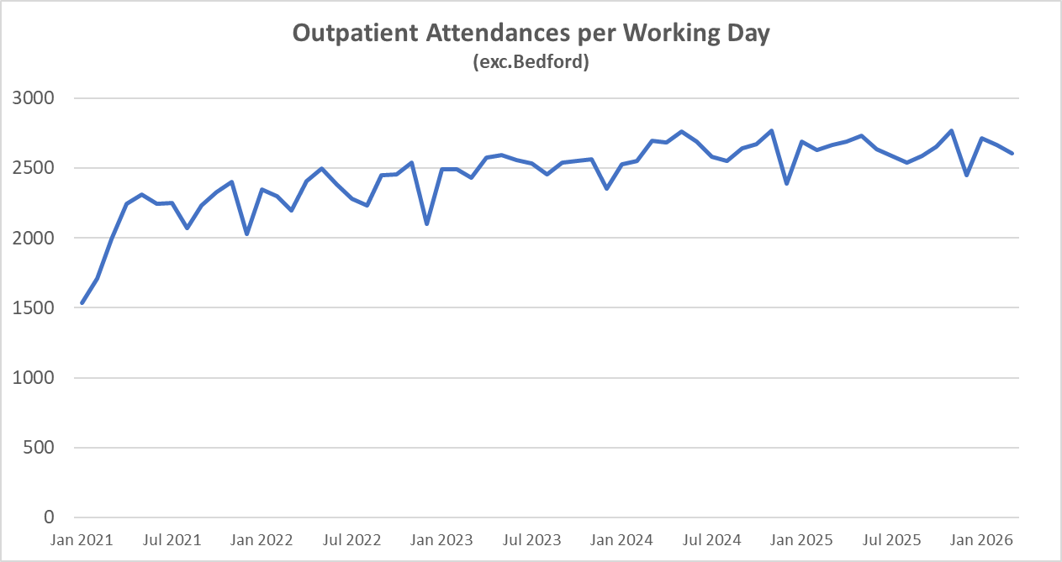

The graph above shows the pattern of average outpatient attendances undertaken by the trust over the last five years. After steady increases across the last four years, the trust has returned to pre-Covid levels of activity.

The table below shows all activity for Moorfields systems (excluding Bedford).

 | Activity Total
Indicator | 2023/24 | 2024/25 | 2025/26
Outpatient total attendances – first appointment | 151,250 | 156,917 | 158,500
Outpatient total attendances – follow up appointments | 484,137 | 514,579 | 507508
Outpatient cancellations (hospital cancellations) | 5.3% | 8.1% | 7.1%
Outpatient DNA rate – first appointment | 13.1% | 13.0% | 12.9%
Outpatient DNA rate – follow up appointment | 11.3% | 10.8% | 9.7%

Safety
Indicator | Target | 2023/24 | 2024/25 | 2025/26
Number of MRSA cases | 0 | 0 | 0 | 0
Number of Clostridium difficile cases | 0 | 0 | 0 | 0
Venous thromboembolism (VTE) screening | ≥ 95% | 98.6% | 99.6% | 99.0%
Mixed sex accommodation | 0 | 0 | 0 | 0

Performance within the safety arena has been strong, with all key targets met. The trust monitors an additional number of infection control metrics all of which have recorded zero cases over the last year.

Service delivery measures
Ward staffing levels are calculated for those wards with inpatient beds, which for Moorfields includes the observation unit and Francis Cumberlege wing at City Road, and Duke Elder ward at St George’s Hospital. The data included reflects the national methodology, which requires trusts to publish fill rates for both registered nursing staff and care staff separated into day and night periods. This data is shown in the table below.

Designation | Percentage fill rate 2025/26
Registered nurses – day | 102.8%
Registered nurses – night | 100.1%
Care staff – day | 100.8%
Care staff – night | 102.0%
Total fill rate | 101.7%

2.4.3 Green Plan progress
The Moorfields Green Plan (2025–2028) sets out how the trust is reducing its environmental impact while continuing to deliver high-quality ophthalmic care. Aligned with the NHS net zero ambition, the plan focuses on practical actions to cut carbon emissions, reduce waste, and use resources more efficiently across clinical services, estates, digital systems, medicines and supply chains.

During the year, the trust made tangible progress in reducing environmental harm from clinical activity. The established Green Theatres programme delivered measurable impacts, including the elimination of nitrous oxide from theatres, increased use of reusable gowns and consumables, and improved both waste segregation, and operational efficiencies that reduce energy use. These changes have reduced carbon emissions, single-use plastics and clinical waste while maintaining patient safety and clinical quality. In April 2026, the Retinal Therapy Unit was established as a second focus area, beginning work to reduce waste from high-volume injection activity.

Digital transformation also delivered environmental benefits. Preparation for the new Electronic Patient Record, MoorConnect, will significantly reduce reliance on paper records and correspondence while enabling more efficient, digitally enabled care. Investment in digital infrastructure and technologies such as ambient dictation is expected to further reduce duplication, paper use and administrative burden.

Progress in medicines sustainability included nationally recognised work on multi-use eye drop bottles, reducing medicines waste, and associated packaging and transport emissions. Improvements to medicines logistics have also reduced delivery frequency and transport impacts.

Across estates and facilities, the trust maintained strong recycling performance, strengthened assurance over waste management, and embedded sustainable design into the Oriel development, supporting long-term decarbonisation through readiness for low-carbon energy solutions.

The trust also strengthened its resilience to climate impacts through approved adverse weather and business continuity plans, ensuring services remain safe and reliable as environmental risks increase. Through these actions, Moorfields continues to reduce its environmental footprint while embedding sustainability into everyday care delivery.

2.4.4 Social contribution
Control measures are in place to ensure compliance with all the organisation’s obligations under equality, diversity and human rights legislation. Control measures are in place to ensure compliance with anti-bribery issues. Controls are applied through policies and training.

2.5 Quality and patient safety

2.5.1 Quality priorities
At Moorfields, quality is integral to every aspect of our decision making and service delivery. Our trust strategy, developed in partnership with patients, carers and staff, sets clear priorities for improving the quality, safety and effectiveness of the care we provide. Our core belief that people’s sight matters continues to underpin everything we do. Our purpose is to work in partnership with our patients, staff and external partners to discover, develop and deliver outstanding eye care that is sustainable and delivered at scale.

During 2025/26, our approach to improving quality has been strengthened through a refreshed governance and transformation programme. This programme is designed to embed the principles of NHS IMPACT, align improvement activity with Getting It Right First Time (GIRFT), and develop lasting local improvement capability across the organisation.

Across the year, progress was made against our quality priorities:

- Failsafe – systematic safety-netting process to ensure that patients who require follow-up, monitoring, or treatment are tracked and followed-up through their care pathway
- Patient safety and experience learning system – to strengthen alignment with the Patient Safety Incident Response Framework (PSIRF)
- Patients experience principles
- Patient transport
- Improving the quality of patient letters and communications
- Consent optimisation – ensuring a consistent process utilising digital documentation

2.5.2 Health inequalities
Moorfields, as do other NHS trusts, has an obligation under NHS England’s statement under section 13SA(1) of the NHS Act 2006, to describe how we exercise our powers to collect, analyse and publish information related to health inequalities.

The second annual report on healthcare inequalities in the delivery of the trust’s high-volume activity was received by the Quality and Safety Committee on 17 March 2026. Routine performance indicators of activity are reported by age, deprivation, ethnicity, clinical risk and need, to identify any variations in access and uptake of services; highlighting areas for deeper scrutiny to inform actionable change where any variations are found to be unwarranted (indicating inequality).

The underlying data is accessible to teams on the QlikSense platform to support service level reviews and planning, and to inform programmes of work and health impact and quality assessments.

Key Findings
- The findings remain positive, continue to challenge some assumptions around inequalities; raise issues that would have been masked by routine performance reporting alone; and provide further value of the quality of services delivered by Moorfields
- Demographic factors are not key drivers for variations in access and uptake of our services but how we do things – our practice and pathways (clinical) and our processes (operational and administrative), i.e. how we provide, organise, deliver & record them
- Cancellations of booked out-patient appointments by Patients or by the Hospital consistently occur more frequently than ‘did not attends’ (DNA), so reporting DNA outcomes alone will significantly underestimate non-attendance outcomes i.e. both uptake and access of booked out-patient appointments
- Variations reported for access and uptake of services by clinical risk and need call for deeper scrutiny and monitoring as changes to service organisation and delivery are implemented and embedded
- Data quality issues persist for ethnicity data and recording of out-patient appointment outcomes
- The feasibility and utility of routine annual reporting on healthcare inequalities in the delivery of trust services have been established but requires continued focus to embed.

2.6 Workforce overview
The following section describes headline staff figures over the course of the year.

2.6.1 Staff report

Staff sickness absence
Average full time equivalent (FTE) | FTE days lost | Average sick days per FTE
2527 | 46,923 (12 months) | 18.6

Staffing WTE & Headcount 2026
Permanently employed  Staff with a permanent (UK) employment contract directly with the entity | Other  Staff that do not have a permanent (UK) employment contract with the entity.
HC: 2260 WTE: 2048.89 | HC: 520 WTE: 495.25

The following figures show our staffing breakdown by staff group, age, gender, ethnicity, disability and sexual orientation, as of 31st March 2026.

Workforce by staff group (subject to audit)
Staff Group | Permanent | Other | Total
Medical and dental | 360 | 26 | 386
Administration and estates | 425 | 84 | 509
Healthcare assistants and other support staff | 932 | 29 | 961
Nursing, midwifery and health visiting staff | 495 | 44 | 539
Scientific, therapeutic and technical staff | 247 | 8 | 256
Healthcare science staff | 62 | 2 | 65
Other | 128 | 0 | 128
Total | 2,649 | 194 | 2,843

Workforce by ethnicity
Ethnicity | Headcount | FTE
BME | 1701 | 1570.16
White | 826 | 739.96
Not Disclosed | 253 | 234.02

Workforce by sexual orientation
Sexual Orientation | Headcount | FTE
Bisexual | 39 | 36.20
Gay or Lesbian | 56 | 52.81
Heterosexual or Straight | 1941 | 1803.19
Other sexual orientation not listed | 4 | 4.00
Undecided | 7 | 6.60
Not Disclosed | 733 | 641.28

Workforce by disability status
Disability | Headcount | FTE
No | 2481 | 2264.66
Not Declared | 199 | 185.39
Yes | 100 | 94.10

Workforce by gender
Gender | Headcount | FTE
Female | 1844 | 1666.85
Male | 936 | 877.29

Workforce by age
Age Band | Headcount | FTE
<=20 Years | 6 | 6.00
21-25 | 104 | 101.13
26-30 | 311 | 293.07
31-35 | 403 | 381.30
36-40 | 406 | 367.80
41-45 | 352 | 285.09
46-50 | 342 | 314.25
51-55 | 326 | 304.88
56-60 | 276 | 254.30
61-65 | 165 | 141.07
66-70 | 61 | 48.21
>=71 Years | 28 | 18.05

2.6.2 Staff Survey
Staff survey
The NHS Staff Survey remains a key indicator of staff engagement and morale, offering valuable insights that support the trust’s strategic planning and workforce development. The 2025 Staff Survey was undertaken during October and November 2025, following a year of significant organisational complexity and cultural disruption.

The trust achieved a 63% response rate (1,710 of 2,725 eligible staff), above the 49% average for similar trusts, though slightly lower than last year’s rate of 69%. The response rate remains robust and provides confidence that the findings are representative of staff experience across the organisation. This also demonstrates that our workforce remains engaged and willing to contribute to organisational improvement.

However, despite measurable improvements in appraisal completion and a reduction in reported working beyond additional paid hours, the survey highlights significant cultural alert signals as listed below:

- Decline in recommendation as a place to work (from 66% in 2024 to 64% in 2025)
- Support for reasonable adjustments is among the Trust’s bottom five scores
- Deterioration in reporting of physical abuse incidents
- High volume of commentary relating to bullying, harassment and toxic culture
- Feedback on senior leadership visibility, workload burnout, and IT systems

NHS People Promise Results

Since 2021, the NHS Staff Survey results have been aligned to the themes of the NHS People Promise

The Trust improved in only one of the nine People Promise themes:
- We Are Always Learning (driven by improved appraisal metrics).
- Five themes remained unchanged, while three declined.
- Over the past four years, People Promise theme scores have typically shifted by only one point annually, suggesting relative stability but limited step-change improvement.

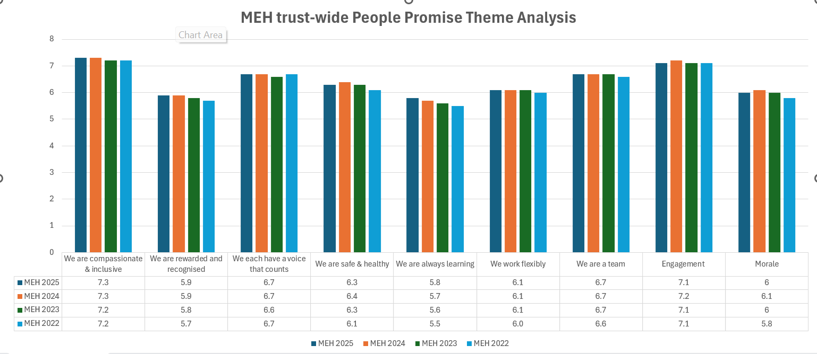

How we have been responding to staff feedback
We are compassionate & inclusive
- Established EHIA as a strategic priority by embedding EHIA into strategic plans, governance frameworks, and policies as a mandatory step in decision-making
- Appointed and trained over 17 EHIA Champions operating as a network across the Trust, to provide hands-on support to colleagues completing EHIAs.
- Conducted recruitment process audit and embarked on project to make recruitment more inclusive.

We are recognised & rewarded
- We relaunched our Employee of the Month Scheme in 2023 and amended this to include Team of the Month in 2026
- Implemented new online appraisal and actively working on improving quality of appraisal so it’s more meaningful
- £15 end of year Thank You voucher issued to all staff

We each have a voice that counts
- Trust wide surveys – quarterly People Pulse Survey & Annual Staff Survey – ensuring we turn your valuable feedback into action
- Monthly staff briefing which always includes Q&A session
- Organised series of staff listening session
- Launch of Freedom to Speak Up online platform
- Support sessions delivered for staff affected by international/national incidents

We are safe
- Launch of Sexual Safety Charter & training
- Implementing monthly ‘reflective spaces’ with a Clinical Psychologist
- Launched the Staff Health Adjustments Passport

2.7 Financial performance (narrative)
Financial report

During the financial period the Trust reported a surplus of £27.3 million compared with a surplus of £19.8 million in the prior year.

Statement of comprehensive income
Income for the year was £383.8 million (2024/25: £365.7 million), an increase of £18.1 million on the prior year, as both NHS and Private patient activity increased alongside an increase in charitable funding.

Income and expenditure
 | All figures in £ million |  | 2025/26 |  | 2024/25
 | Income
 | Income from activities
 | NHS income |  | 278.1 |  | 274.2
 | Private patient income |  | 48.6 |  | 45.1
 | Total income from activities |  | 326.7 |  | 319.3
 | Other operating income |  | 57.1 |  | 46.4
 | Total other operating income |  | 57.1 |  | 46.4
 | Total income |  | 383.8 |  | 365.7
 | Expenses
 | Pay costs |  | 210.3 |  | 201.4
 | Non-pay costs |  | 136.8 |  | 127.2
 | Depreciation and amortisation |  | 16.9 |  | 17.3
 | Total operating expenses |  | 355.6 |  | 345.9
 | Operating surplus |  | 28.2 |  | 19.8
 | Interest and dividends |  | (1.3) |  | 0.4
Other one-off gains for disposal of assets and share of joint venture profit and tax |  | 0.4 |  | (0.4)
Surplus for the year |  | 27.3 |  | 19.8

Pay costs increased by £8.9 million (4.4%) to £210.3 million (2024/25: £201.4 million), and non-pay costs increased by £9.6 million (7.5%) to £136.8 million (2024/25: £127.2 million).

Income disclosures
Section 43(2A) of the NHS Act 2006 (as amended by the Health and Social Care Act 2012) requires that the income from the provision of goods and services for the purposes of the health service in England must be greater than its income from the provision of goods and services for any other purposes.

The Trust met this requirement. In 2025/26, 14.9% of income from provision of goods and services was derived from non-NHS income (2024/25 14.2%).

Section 43(3A) of the NHS Act 2006 requires NHS foundation trusts to provide information on the impact that other income it has received has had on its provision of goods and services for the purposes of the health service in England.

Surpluses from other income the Trust received have been used to support the provision of goods and services for the purposes of the health service in England.

Statement of financial position
Total assets employed have increased by £31.7 million to £330.2 million as of 31 March 2026 (2024/25: £298.5 million). Non-current assets increased by £206.9 million to £610.0 million (2024/25: £403.1 million).

Current assets reduced by £23.3 million to £91.9 million (2024/25: £115.2 million).

Current liabilities have increased by £3.5 million to £56.8 million (2024/25: £53.3 million). Non-current liabilities increased by £148.4 million to £314.9 million (2024/25 £166.5 million).

Taxpayers’ equity increased by £31.7 million during the year.

Statement of cash flows
The Trust generated a net cash in-flow of £20.4 million from operations in 2025/26. The net cash surplus from operations, together with historic cash reserves, was used to fund internal capital expenditure of £34.1 million (2024/25: £10.3 million) and loan repayment, net interest, and Public Dividend Capital (PDC) dividend payments of £10.9 million (2024/25: £12.2 million). The trust also received £4.8 million of PDC for externally funded capital and £74.2 million of capital loans.

The Trust ended the year with a lower level of cash at £62.8 million (2024/25 £86.1 million), a reduction of £23.3 million.

Counter-fraud arrangements
The Trust has an established counter-fraud policy and response plan to minimise the risk of fraud or corruption. The Trust’s local counter-fraud specialist (LCFS) reports to the chief financial officer and performs a programme of work designed to provide assurance to the board with regard to fraud and corruption. The LCFS also gives regular fraud awareness sessions for Moorfields’ staff and investigates concerns reported by staff. If these are substantiated, the Trust takes appropriate criminal, civil or disciplinary measures.

Political donations
The Trust made no political donations during 2025/26 (2024/25: nil).

Commissioning arrangements
The Trust has commissioning arrangements in place with most Integrated Commissioning Boards across England on the basis of both fixed and variable components in line with national guidance.

Further information on the Trust’s financial position can be found in the annual accounts.

Better payment practice code
The better payments practice code requires the Trust to aim to pay all undisputed invoices by the due date or within 30 days of receipt of goods or a valid invoice, whichever is later.

The Trust achieves the aims of the better payment practice code in the majority of cases and works with staff and suppliers throughout the year to minimise the remaining cases.
 | 2025/26 | 2025/26 | 2024/25 | 2024/25
 | Number | £000 | Number | £000
Non-NHS
Total bills paid in the year | 37,278 | 253,529 | 40,154 | 238,626
Total bills paid within target | 35,500 | 238,488 | 38,158 | 228,883
Percentages of bills paid within target | 95% | 94% | 95% | 95%
NHS
Total bills paid in the year | 1,450 | 26,112 | 1,392 | 27,861
Total bills paid within target | 1,334 | 23,681 | 1,260 | 24,931
Percentages of bills paid within target | 92% | 91% | 91% | 90%
Total
Total bills paid in the year | 38,728 | 279,641 | 41,546 | 266,486
Total bills paid within target | 36,834 | 262,169 | 39,418 | 251,813
Percentages of bills paid within target | 95% | 94% | 95% | 95%

Finance and Use Of Resources
The Trust has complied with all cost allocation and charging guidance issued by HM Treasury.

The Trust has no income generating schemes with an individual cost exceeding £1m.

2.8 Sustainability
Our vision is to establish Moorfields as a leader in sustainable eye care in order to reduce the impacts of climate change on eye care and wider health outcomes. In alignment with the NHS net zero targets, Moorfields aims to reach net zero:
- by 2040 for the emissions we control directly (our Carbon Footprint),
- by 2045 for the emissions we can influence (our Carbon Footprint Plus).

An update on achievements against the objectives are below:

- Supply Chain & Procurement

Moorfields is a member of the shared procurement service PPS, which has developed a sustainable procurement policy that aids the trust in improving the environmental credentials of the products and service we buy. We are working with the North Central London Integrated Care Board towards sustainable procurement. All procurements are mandated to include a minimum 10% social value weighting. Moorfields will be looking at how this weighting can help deliver a reduction in our carbon emissions from our supply chain.

- Medicines & Pharmacy
The Moorfields medical retina service, with support from pharmacy and infection prevention and control, has led a pioneering sustainability project with the potential to significantly reduce the carbon footprint and plastic waste associated with eye care via eye drops.

In 2025, our A&E nursing team worked with our pharmacy team to re-label and return mislabelled stock deposited in a designated box helping to reduce both waste and cost.

- Estates, Facilities and Waste Management

Oriel is continuing to progress towards its 2027 target completion and is expected to provide sustainability gains. From a sustainability perspective, the centre represents a bold step forward. The development has been shaped around net-zero readiness, incorporating the latest energy-efficient technologies and building standards. The centre will help Moorfields meet the NHS climate commitments while elevating our environmental performance across estates and operations. Over the next two years, our focus is on adapting working practices to ensure a smooth transition, embedding sustainable behaviours and systems that will continue seamlessly at the new centre. This phase presents a unique opportunity to align every aspect of our delivery with sustainability principles – and many of the initiatives outlined in this green plan have been designed with that goal in mind.

Electrical sub metering has been installed with automatic meter readings.

Moorfields is a NCL leader in recycling and offensive waste segregation exceeding NHS targets and outperforming peers.

The estates team is continuing to work to improve our waste segregation and reduce the carbon impact of our waste.

- Paperless & Digital Transformation

Paperless transformation is a key priority area for the trust, and a paperless lead has been appointed to further drive this work. Electronic patient records (MoorConnect) is a major project for the trust, and it is expected to deliver major paper and therefore carbon savings.

The first phase of the paperless project was completed in 2024/25. The second phase of the paperless project is underway with the design and implementation of the new electronic patient record system designed to remove the need for paper records.

- Sustainable Care & Ways of Working

Green Plan Refresh

As part of the NHS commitment to sustainability, all trusts are required to publish a board-approved refresh Green Plan setting out their sustainability strategy for the next three years. This is a key area of focus for Moorfields, as we build on the foundations of our previous Green Plan, outlining the next phase of our journey towards environmental sustainability. Our plan was refreshed during the year and the 2025-28 plan was approved by the board in July.

Emergency planning, preparedness and resilience (EPPR)
Each year we undertake an EPPR process review, the aim of which is to assure NHS England that we are prepared to respond to an emergency and have the resilience in place to continue to provide safe patient care during a major incident or business continuity event. The 2025/26 review saw us awarded a green rating.

- Equality, diversity and inclusion (EDI)
The trust's aspiration for equality, diversity and inclusion (EDI) is to create a culture that enables all staff and patients to feel welcome, have a sense of belonging, to be respected, and that supports staff in realising their potential while ensuring that patients achieve the best possible health outcomes.

The trust is committed to ensuring equity, diversity and inclusion (EDI). This is a priority for the trust, and we remain steadfast on our journey. We will continue to take actions to ensure everyone at Moorfields has an equitable experience, and foster an environment where equality, diversity, and inclusion is integral in everything we do.

Our EDI vision strapline is "Equity in Action," demonstrating our commitment to creating an inclusive culture where every individual feels respected, valued, and able to thrive. We are taking steps to build an equitable, diverse, and inclusive workplace. As a leading provider of ophthalmic care, education, and research, the trust is dedicated to ensuring that our staff represents the communities we serve. We aim to eliminate discrimination, foster good relations, and promote opportunities for all, embedding EDI into every aspect of our service, empowered by our EDI vision and trust values.

Our EDI policy sets out how we strive to deliver a culture where neither patients nor staff are treated negatively because of any protected characteristic they may have.

Our EDI programme was introduced in response to key issues identified following engagement with staff on their experience and the trust’s performance on EDI and in alignment with the trust strategy. The programme is made up of three key workstreams:
- Leadership and culture
- Data-driven change
- Fair opportunities for all

The EDI steering group is the strategic group for EDI in the trust. Its remit is to provide focus, leadership, and coordination for achievement of corporate delivery of the EDI programme and wider EDI agenda. The group ensures that the trust is responding appropriately to equality legislation and national requirements. The group is chaired by the chief people officer and reports to the People and Culture Committee.

There are four staff networks in the trust:
- BeMoor – our race and ethnicities network
- MoorAbility – our network for colleagues with disabilities or long-term health conditions
- MoorPride – our network for LGBTQ+ colleagues
- Aurora Women’s network – our newly formed network to discuss gender specific issues and consider how best to tackle them in the workplace.

The trust’s EDI strategic objectives are informed by qualitative and quantitative data, which includes our Staff Survey results, our Workforce Race Equality Standard (WRES) and Workforce Disability Equality Standard (WDES) submissions, our Gender Pay Gap (GPG) submission, and feedback from our staff networks.

- Additional workforce commentary
We have workforce policies applied during the financial year for giving full and fair consideration to applications for employment made by disabled people, having regard to their particular aptitudes and abilities as well as policies pertaining to staff development. We continue to work constructively with the Joint Staff Side Committee in a collaborative approach toward delivering the transformational change, particularly digitisation, that will enable us to move into the new facility in Camden.

The Trust continues to maintain a strong focus on health and safety, with robust governance arrangements in place to monitor compliance with statutory requirements and promote a positive safety culture across all sites. Health and safety performance is regularly reviewed, with incidents reported, investigated and used to inform learning and improvement.

Occupational health services continue to support staff wellbeing through timely assessment, advice and interventions, including promoting safe return to work and reducing work-related ill health. The Trust remains committed to improving staff health and wellbeing, recognising its importance to the delivery of safe, high-quality care.
Mr Peter Ridley
chief executive and accounting officer
25 June 2026

Accountability report

3.1 Directors’ Report
We benefit from a strong board of directors, whose wide-ranging experience underpins our continued success.

The board of directors holds overall accountability for the organisation and is responsible for its strategic direction and the high-level allocation of resources. It delegates decision making for the operational running of the trust to the chief executive.

The directors are additionally responsible for preparing the annual report and accounts. Taken as a whole, they consider these are fair, balanced and understandable and provide the information necessary for patients, regulators and other stakeholders to assess our performance, business model and strategy.

The board comprises 16 members, nine non-executive directors (including the chair, eight are considered to be independent, the ninth being a representative of the UCL Institute of Ophthalmology as defined in the trust’s constitution) and seven executive directors.

Non-executive directors (NEDs), including the chair, are appointed by the membership council following recommendations from the remuneration and nomination committee for non-executive directors. Executive directors are appointed by the remuneration committee of the board, a committee made up of non-executive directors.

Professor Tim Briggs commenced as interim chair on 7 April 2025 replacing the previous chair Laura Wade-Gery; she was appointed from 1 February 2023 and resigned in April 2025. Tim Briggs’ significant other interests include national director for clinical improvement and elective recovery, chair of NHS England’s getting it right first time (GIRFT) programme, and consultant orthopaedic surgeon at the Royal National Orthopaedic Hospital NHS Trust. The full declarations of interest for our directors are on our website. After consultation with NHSE, the membership council appointed Professor Tim Briggs as interim chairman for an initial period of nine months effective from 10th April 2025 which was later extended into 2026/27.

The board of directors believes it has the appropriate balance and completeness in its composition to meet the requirements of an NHS foundation trust. As of 31 March 2026, the following individuals comprised the voting members of the board of directors (expiry of current terms of office for non-executive directors are listed):

Tim Briggs (male) – interim chair from 7 April 2025 to present
Asif Bhatti (male) – independent non-executive director (22 May 2028)
Aaron Rajan (male) – independent non-executive director (28 February 2027)
Andrew Dick (male) – non-executive director (30 September 2026)
David Hills (male) – independent non-executive director (31 March 2026) [note: he has since been appointed as an associate non-executive director]
Adrian Morris (male) – independent non-executive director (31 March 2027 serving as senior independent director from 01 August 2024)
Michael Marsh (male) – independent non-executive director (3 November 2027)
Elena Lokteva (female) – independent non-executive director (31 December 2027)
One NED vacancy

Peter Ridley (male) – chief executive
Arthur Vaughan (male) – chief financial officer
Louisa Wickham (female) – chief medical officer
Suminthra Naidu (female)– chief nurse and director of allied health professionals
Jon Spencer (male) – chief operating officer
Sue Steen (female) – chief people officer
The director of discovery post was reconfigured into a director of research and innovation with recruitment taking place in 2026/27.

The non-voting directors listed below:
Elena Bechberger (female) – director of strategy
Brendan Mahony (male) – chief information officer
Ian Tombleson (male) – director of quality & patient safety
Kieran McDaid (male) – director of estates, capital and major projects
Michèle Russell (female) – director of education
Victoria Moore (female) – director of transformation and performance improvement

Full profiles of all board members can be found here: https://www.moorfields.nhs.uk/content/trust-board

3.1.1 NHS Oversight Framework disclosure
NHS England’s NHS Oversight Framework 2025/26 is the framework for assessing health systems including providers. It promotes transparency and improvement and helps identify potential support or intervention needs. NHS organisations are allocated to one of five ‘segments’. Segmentation indicates performance and whether improvement is required, from high performing across all domains (segment 1) to low performance across a range of domains (segment 4). An organisation assessed as segment 4 combined with a low capability to improve is allocated to segment 5. NHS England’s oversight response to an organisation is based on: a) Its segment derived from scored metrics under five performance domains (being access to services, effectiveness and experience of care, patient safety, people and workforce, and finance and productivity) b) considering financial override which may limit a segment to be no better than 3 c) contextual metrics which are not scored (for example those under sixth domain of improving health and reducing inequality) and d) capability assessments which consider the organisation’s leadership and governance.

Segmentation
Moorfields NHS Foundation Trust has been placed in National Oversight Framework segment 1, the highest segment. This segmentation information is the trust’s position as at 31 March 2026. Current segmentation information for NHS trusts and foundation trusts is published on the NHS England website: https://www.england.nhs.uk/nhs-oversight-framework/segmentation and-league-tables/. The trust is included on the acute trust dashboard.

3.1.2 Taskforce on climate-related financial disclosures
NHS England’s NHS foundation trust annual reporting manual adopted a phased approach to incorporate the Taskforce on climate-related financial disclosures (TCFD) recommended disclosures as part of sustainability annual reporting requirements for NHS bodies, stemming from HM Treasury's TCFD aligned disclosure guidance for public sector annual reports. TCFD recommended disclosures are as interpreted and adapted for the public sector by HM Treasury. Local NHS bodies are not required to disclose scope 1, 2 and 3 greenhouse gas emissions under TCFD requirements as these are computed nationally by NHS England.

Governance
Board-level oversight of climate-related risks and opportunities is provided through the trust’s net zero executive lead, the chief financial officer. Delivery of the trust’s climate strategy and Green Plan is overseen by the Green Plan Delivery Group, a multidisciplinary group of senior clinical and non-clinical leads, covering the nine Green Plan focus areas and supported by enabling functions. The group meets monthly and reports quarterly to the Planned Delivery Group, providing assurance on progress, risks and delivery.

Strategy
The trust recognises that climate change presents both risks and opportunities that may affect the delivery of specialist ophthalmic services over the short-, medium- and long-term. Key risks are predominantly physical, including rising temperatures and extreme weather, with potential impacts on estate resilience, controlled clinical environments and service continuity. Transition risks arising from decarbonisation requirements, future capital investment needs and evolving NHS policy are also recognised. Climate considerations are embedded within the trust’s Green Plan, estates planning and service development, supporting resilience and NHS net zero ambitions.

Risk Management
Climate-related risks are managed through the trust’s established risk management framework and assessed alongside other strategic and operational risks. Risks are identified through local assessments, estates planning and national guidance, with mitigations delivered through the Green Plan, business continuity and emergency preparedness arrangements.

Metrics and Targets
Progress is monitored through Green Plan KPIs aligned to national arrangements. Emissions reporting is undertaken centrally by NHS England, with trust-level reporting to be developed from 2026.

3.1.3 Going concern disclosure
“After making enquiries, the directors have a reasonable expectation that the services provided by the NHS foundation trust will continue to be provided by the public sector for the foreseeable future. For this reason, the directors have adopted the going concern basis in preparing the accounts, following the definition of going concern in the public sector adopted by HM Treasury’s Financial Reporting Manual.”

3.1.4 Statement of accounting officer’s responsibilities
Statement of the chief executive's responsibilities as the accounting officer of Moorfields Eye Hospital NHS Foundation Trust

The NHS Act 2006 states that the chief executive is the accounting officer of the NHS foundation trust. The relevant responsibilities of the accounting officer, including their responsibility for the propriety and regularity of public finances for which they are answerable, and for the keeping of proper accounts, are set out in the NHS Foundation Trust Accounting Officer Memorandum issued by NHS England.

NHS England has given Accounts Directions which require Moorfields Eye NHS Foundation Trust to prepare for each financial year a statement of accounts in the form and on the basis required by those Directions. The accounts are prepared on an accruals basis and must give a true and fair view of the state of affairs of Moorfields Eye Hospital NHS Foundation Trust and of its income and expenditure, other items of comprehensive income and cash flows for the financial year.

In preparing the accounts and overseeing the use of public funds, the Accounting Officer is required to comply with the requirements of the Department of Health and Social Care Group Accounting Manual and in particular to:
- observe the Accounts Direction issued by NHS England, including the relevant accounting and disclosure requirements, and apply suitable accounting policies on a consistent basis
- make judgements and estimates on a reasonable basis
- state whether applicable accounting standards as set out in the NHS Foundation Trust Annual Reporting Manual (and the Department of Health and Social Care Group Accounting Manual) have been followed, and disclose and explain any material departures in the financial statements
- ensure that the use of public funds complies with the relevant legislation, delegated authorities and guidance
- confirm that the annual report and accounts, taken as a whole, is fair, balanced and understandable and provides the information necessary for patients, regulators and stakeholders to assess the NHS foundation trust’s performance, business model and strategy and
- prepare the financial statements on a going concern basis and disclose any material uncertainties over going concern.

The accounting officer is responsible for keeping proper accounting records which disclose with reasonable accuracy at any time the financial position of the NHS 65 foundation trust and to enable them to ensure that the accounts comply with requirements outlined in the above mentioned Act. The Accounting Officer is also responsible for safeguarding the assets of the NHS foundation trust and hence for taking reasonable steps for the prevention and detection of fraud and other irregularities.

As far as I am aware, there is no relevant audit information of which the foundation trust’s auditors are unaware, and I have taken all the steps that I ought to have taken to make myself aware of any relevant audit information and to establish that the entity’s auditors are aware of that information.

To the best of my knowledge and belief, I have properly discharged the responsibilities set out in the NHS Foundation Trust Accounting Officer Memorandum.

Mr Peter Ridley
Chief executive and accounting officer
25 June 2026

3.1.5 Directors’ report, additional detail
Details of company directorships and other significant interests held by directors or governors which may conflict with their management responsibilities are declared and presented at board meetings in public. They are also available on our website.

Moorfields Eye Hospital NHS Foundation has complied with the cost allocation and charging guidance issued by HM Treasury.

The trust has not made any political donations

Board and Committee attendance

Board
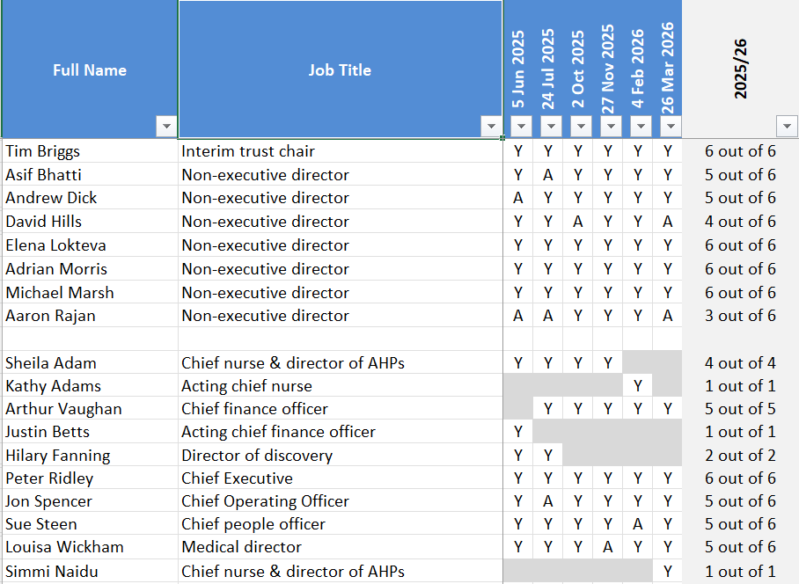

Audit and Risk Committee
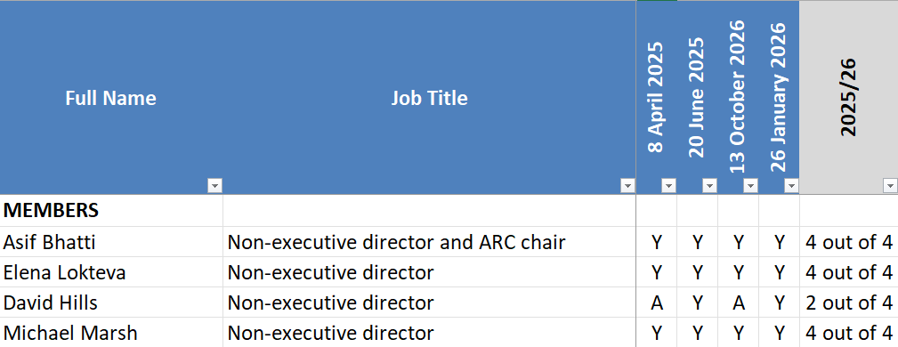

Discovery and Commercial Committee
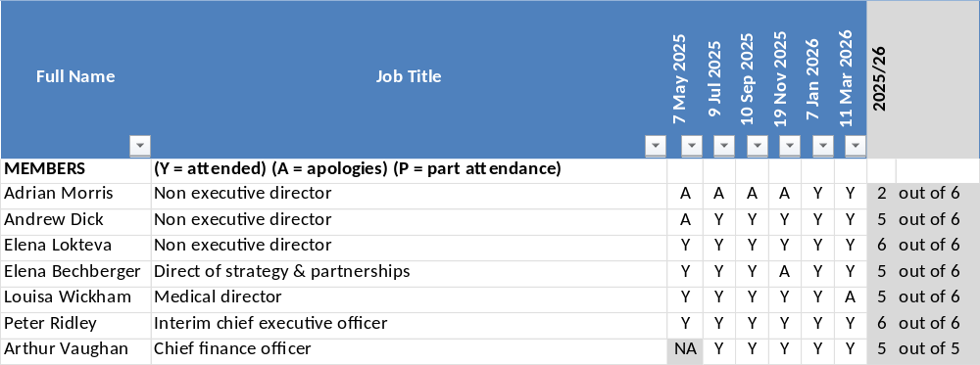

Finance and Performance Committee
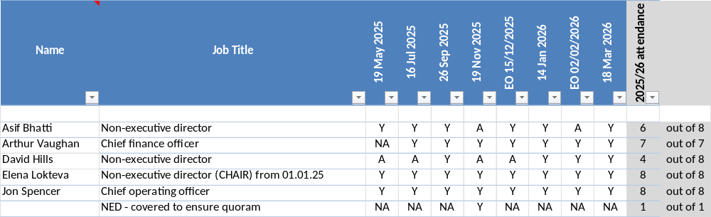

Major Projects and Digital Committee
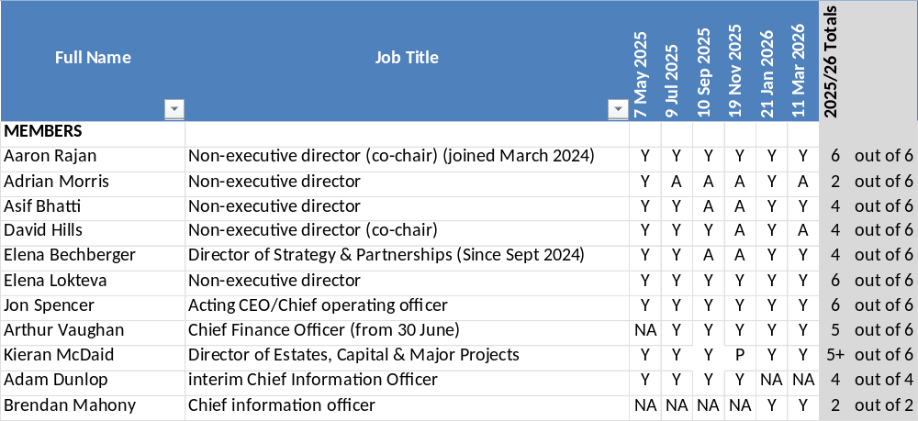

People and Culture Committee
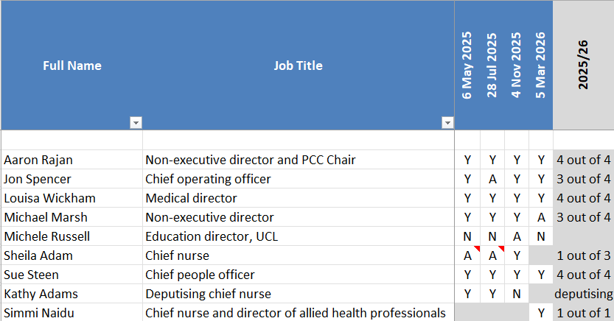

Remuneration and Nominations Committee
Name | Role | Attendance
Tim Briggs | Chair | 8 out of 8
Asif Bhatti | Non-executive director | 3 out of 8
Elena Lokteva | Non-executive director | 6 out of 8
Aaron Rajan | Non-executive director | 8 out of 8
Michael Marsh | Non-executive director | 8 out of 8
Adrian Morris | Non-executive director | 6 out of 8
David Hills | Non-executive director | 4 out of 8

3.1.6 Modern Slavery statement
Section 54 of the Modern Slavery Act 2015 requires all organisations to set out the steps the organisation has taken to ensure that slavery and human trafficking is not taking place in any of its supply chains and in any part of its own business.

Moorfields Eye Hospital NHS Foundation Trust aims to follow good practice and take all reasonable steps to prevent slavery and human trafficking. We are committed to ensuring that all of our employees are aware of the Modern Slavery Act 2015 and their safeguarding duty to protect and prevent any further harm and abuse when it is identified or suspected that a child, young person or adult may be or is at risk of modern slavery/human trafficking. We are also committed to ensuring that no modern slavery or human trafficking takes place in any part of our business or our supply chain.

Policies and procedures
The trust has policies, due diligence and risk assessment processes in place detailing risk management, safeguarding, whistleblowing and procurement.

Our commitment to contribute to the eradication of modern slavery is reflected in the safeguarding adults, and safeguarding children and young people policies, which have been developed in accordance with safeguarding legislation and national guidance. All staff have access to the safeguarding team for support and advice if they have a concern, and the trust's safeguarding intranet pages include information, guidance and the Modern Slavery Helpline.

The trust’s freedom to speak up (including whistleblowing) policy details how staff can raise concerns that they may have confidentially. This can be through a conversation with a freedom to speak up guardian or contact colleague who will provide support to the individual raising a concern.

Trust activities and policies are required to have an equality impact assessment (EQIA) completed.

Training
Safeguarding training is mandatory for all staff and includes information on modern-day slavery and human trafficking in order to promote the knowledge and understanding of escalating concerns internally and externally via the Home Office national referral mechanism. All staff have a responsibility to consider issues regarding modern slavery and incorporate their understanding into their day-to-day practice.

All new staff are provided with information on the freedom to speak up (including whistleblowing) policy and freedom to speak up guardians and contact colleagues at corporate induction.

Assessing and managing risk and due diligence processes

To identify and mitigate the risks of modern slavery and human trafficking in our own business and our supply chain the trust:
- Adheres to the national NHS employment checks/standards (this includes employees UK address, right to work in the UK and suitable references).
- Follows NHS Agenda for Change terms and conditions to ensure that staff receive fair pay rates and contractual terms.
- Consults trade unions on any proposed changes to employment terms and conditions.
- Has systems to encourage the reporting of concerns and the protection of whistleblowers.
- Purchases a significant number of products through NHS Supply Chain, whose ‘supplier code of conduct’ includes a provision around forced labour. Other contracts are governed by standard NHS terms and conditions.
- Upholds professional practices relating to procurement and supply and ensures procurement staff attend regular training on changes to procurement legislation.
- Ensures the majority of our purchases utilise existing supply contracts or frameworks which have been negotiated under the NHS standard terms and conditions of contract, which all have the requirement for suppliers to have modern slavery and human trafficking policies and processes in place.
- Requests all suppliers comply with the provisions of the Modern Slavery Act (2015), through agreement of our ‘supplier code of conduct’, purchase orders and tender specifications.

The trust's board of directors has approved this statement and will continue to support the requirements of the legislation.

3.2 Members’ Report
It is with great sadness that we learned of the passing of John Sloper during the year. As a dedicated Governor, he made a valued contribution to the Trust, and he will be greatly missed. We extend our sincere condolences to his family and colleagues.

3.2.1 Membership report
The membership council has a duty under the NHS Act 2006 to represent the interests of NHS foundation trust members, the public and our staff. The membership council continues to play a vital role in our work, advising us on how best to meet the needs of patients and the wider stakeholder community.

During 2025/26, Moorfields Eye Hospital NHS Foundation Trust continued to maintain an active and engaged membership, recognising the important role members play in shaping the Trust’s priorities and ensuring accountability to the communities we serve.

Membership remained representative across patient, public and staff constituencies, with ongoing efforts to improve diversity and inclusion, ensuring that the membership better reflects the population served by the Trust. Recruitment activity focused on targeted engagement campaigns and strengthening links with under-represented groups.

The Membership Council has worked closely with the Board of Directors throughout the year, holding Non-Executive Directors to account and contributing to key areas including strategy, quality, and leadership. Governors have also been involved in significant activities such as senior appointments, engagement with members, and providing feedback on Trust performance and priorities. The Membership Council met eight times during the year to not only carry out its regular duties but also to attend to the matter of appointing an interim chair. During the year we commenced the process for appointing a substantive chair.
The Trust has continued to strengthen communication with members through regular updates, events, and digital engagement, providing opportunities for members to share their views and influence decision-making. Feedback from these interactions has informed service development and improvement activity.
The governors led another successful members’ week in September 2025. This is where governors engage with members, patients and public by conducting a week-long series of visits to various services and sites. A comprehensive report on observations is presented to the membership council and executive directors. Updates on progress were received by the membership Council at their meetings throughout the year.

Looking ahead, the Trust remains committed to developing its membership offer, enhancing engagement, and ensuring that members and governors continue to play a meaningful role in supporting the delivery of high-quality patient care.

3.2.2 Membership Council composition and attendance report 2025/26
The following table lists the governors in office in 2025/26 and their attendance at meetings in public, of which there were eight in the year.

Name and constituency | Elected/Appointed from | Membership Council meetings attended
Rob Jones (Patient)  Lead governor | Elected from 1st April 2024 | 8 out of 8
Emily Brothers  (Patient) | Elected 1st April 2023 | 6 out of 8
Ursula Smartt  (Patient) | Elected 28th March 2024 | 3 out of 8
Paul Murphy  (Public: North Central London) | Elected from 1st April 2024 | 8 out of 8
Robert Goldstein  (Public: North Central London) | Elected 28 March 2022 (2 years) elected to NCL from 1st April 2024 | 4 out of 8
Allan MacCarthy  (Public: South East London) Vice-chair | Elected 28 March 2022 | 8 out of 8
Naga Subramanian  (Public: South East London) | Elected 1st April 2024 | 8 out of 8
John Russell  (Public: North East London and Essex) | Elected 28 March 2022 | 7 out of 8
Sean Cooke  (Public: North East London and Essex) | Elected 28 March 2024 | 0 out of 8
Emmanuel Zuridis  (Public South West London) | Elected 28 March 2022 | 8 out of 8
Kimberley Jackson  (Public South West London) | Elected 28 March 2022 | 7 out of 8
John Sloper  (Public: Beds and Herts) | Elected 28 March 2022 | 5 out of 5
Margaret Connor  (Public: Beds and Herts) | Elected 27 March 2025 | 0 out of 8
Vijay Arora  (Public: North West London) | Elected 1st April 2024 | 6 out of 8
Dinesh Solanki  (Public: North West London) | Elected 28th March 2024 | 8 out of 8
Amit Arora  (Staff: City Road) | Elected 28th March 2024 | 7 out of 8
John Shubhaker  (Staff: City Road) | Elected 27 March 2025 | 7 out of 8
(Fola) Sade Bakare  (Staff: network sites) | Elected 27th March 2025 | 3 out of 8
Yasir Khan  (Staff: network sites) | Elected 28th March 2024 | 5 out 8
Tricia Smikle  Royal National Institute of Blind People | Appointed 14 November 2017 | 7 out of 8
University College London Position vacant | N/A
Cllr Santiago Bell-Bradford  London Borough of Islington | Appointed: 1 September 2022 | 0 out of 8
Ian Humphreys  College of Optometrists | Appointed 5 December 2019 | 5 out of 8

Note: John Schubaker stood down as a governor following taking up a role as a senior medical leader at the Trust. Junia Rahman was elected to replace him on 27 March 2026.

Elected governors hold their positions for three years. Nominated governors are proposed by their host organisation and hold the position until a new nomination is made.

The membership council has one committee and three groups:

The remuneration and nominations committee of the membership council is established to ensure that the selection and appointment process for non-executive directors is robust, and to periodically review non-executive director remuneration levels to ensure an appropriate balance between value for money and attracting candidates of sufficient calibre.

During 2025/26, the remuneration and nominations committee commenced the recruitment of two new non executive directors and oversaw the successful extension of Professor Tim Briggs as interim chair.

The governance development group is established to propose and carry out initiatives that will improve the role of the membership council in our governance and the development of governors individually and collectively. In 2025/26 the group was largely focused on the oversight of, NED/governor sessions and post board governor forums, arrangements for board and membership council meetings and governor elections.

The membership and patient engagement group, which worked on initiatives designed to develop the membership of the foundation trust, improve communications between the trust and members and public, as well as governors and ensure that the trust and its members benefit from that relationship.

The governors review group was established upon receipt by the Governors of a letter from the consultant body expressing a lack of confidence in the leadership of the trust. The work of this group has been significant and with their diligence and dedication, they commissioned two external governance reviews in order to thoroughly explore the issues raised in the letter. At the end of the year, the reviews were ongoing; the review group mat with the external reviewers during the year to receive updates on progress.

The register of interests of individual governors on the membership council is available on the website and to the public on request. Please write to: company secretary, Moorfields Eye Hospital NHS Foundation Trust, 162 City Road, London EC1V 2PD, email: moorfields.foundation@nhs.net or phone: 020 7566 2490.

3.3 NHS Provider Code of Governance
Moorfields Eye Hospital NHS Foundation Trust has applied the principles of the NHS Provider Trust Code of Governance on a ‘comply or explain’ basis. It keeps its governance arrangements under regular review, including membership of board committees, their terms of reference and board performance assessments.

We are required to provide a specific set of disclosures in our annual report to meet the requirements of the NHS Provider Trust Code of Governance. All provisions which require a supporting explanation in the annual report, even where we are compliance with the provision, are described in the appropriate section. A reference to the location of these disclosures is contained in the table below to avoid unnecessary duplication.

The following table summarises where disclosures can be found

Provision | Summary | Notes including location
A, 2.1 | Partnerships | Section 2.2.2
A, 2.3 | Culture | Sections 2.6.2, 3.4.4, 3.4.6
A, 2.8 | System partnerships | Section 2.2.2
B, 2.6 | Independent directors | Section 3.1
B, 2.13 | Board and committee meetings | Section 3.1.5
B, 2.17 | Council of Governors | Section 3.2
C, 2.5 | External consultancies | Section 3.4.6
C, 2.8 | Council of Governors | Section 3.2
C, 4.2 | Directors | Section 3.1
C, 4.7 | Well-led | Section 3.4.5
C, 4.13 | Board diversity | Section 3.1
C, 5.15 | Council of Governors and members | Section 3.2
D, 2.4 | Financial statements | Section 2.7
D, 2.6 | Annual Audit | Section 2.7
D, 2.7 | Risks | Section 3.4
D, 2.8 | Control systems | Annual Governance Statement
D, 2.9 | Going concern | Section 3.1.3
E, 2.3 | Executives as NEDs elsewhere | N/A
A, 2.2 | Values | Section 2.8
A, 2.4 | Performance | Performance report
A, 2.5 | Performance | Performance report
A, 2.6 | Clinical governance | Section 2.5
A, 2.7 | Members meetings | Section 3.2
A, 2.9 | Raising concerns | Section 3.4.6
A, 2.10 | Interests | Sections 3.1.5 and 3.2
A, 2.11 | Directors’ concerns | N/A
B, 2 | Board and governors | Directors report and 3.2
C, 2 and C, 3 | Remuneration and nominations | Directors report and 3.2
C, 4 | FPPT governor elections and effectiveness | Compliant and 3.2 and directors’ report
C, 5 | induction | Directors’ report and 3.2
D, 2 | Audit committee | 3.1.5 and 3.4
E, 2 | Remuneration | Remuneration report

Mr Peter Ridley
chief executive
25 June 2026

3.4 Annual Governance Statement (AGS)

3.4.1 Scope of responsibility
As accounting officer, I have responsibility for maintaining a sound system of internal control that supports the achievement of the NHS foundation trust’s policies, aims and objectives, whilst safeguarding the public funds and departmental assets for which I am personally responsible, in accordance with the responsibilities assigned to me. I am also responsible for ensuring that the NHS foundation trust is administered prudently and economically and that resources are applied efficiently and effectively. I also acknowledge my responsibilities as set out in the NHS Foundation Trust Accounting Officer Memorandum.

3.4.2 The purpose of the system of internal control

The system of internal control is designed to manage risk to a reasonable level rather than to eliminate all risk of failure to achieve policies, aims and objectives; it can therefore only provide reasonable and not absolute assurance of effectiveness. The system of internal control is based on an ongoing process designed to identify and prioritise the risks to the achievement of the policies, aims and objectives of Moorfields Eye Hospital NHS Foundation Trust, to evaluate the likelihood of those risks being realised and the impact should they be realised, and to manage them efficiently, effectively and economically. The system of internal control has been in place in Moorfields Eye Hospital NHS Foundation Trust for the year ended 31 March 2026 and up to the date of approval of the annual reports and accounts.

3.4.3 Capacity to handle risk

The board of directors are responsible for ensuring that a system of internal control is in place. As accounting officer, I have overall accountability for risk management in the trust and chair the management executive, through which executive responsibility for risk management is exercised. The control of risk is embedded in the roles of executive directors through to the managerial staff within the organisation.

The risk management strategy of the organisation is to maintain systematic and effective arrangements for identifying and managing risk to an acceptable level which fits within our risk appetite. The strategy provides a framework for managing risk across the organisation which is consistent with best practice and Department of Health and Social Care guidance. The director of quality and safety has responsibility for the design, development and maintenance of operational risk systems, policies and processes. Divisional and directorate governance arrangements implement and maintain risk management processes, including the maintenance of risk registers. The day-to-day working of risk systems is therefore managed through our operational and departmental teams. The risk management strategy provides a clear, systematic approach to the identification and assessment of risks to ensure that risk management is an integral part of clinical, managerial and financial processes across the organisation. The audit and risk committee, comprising non-executive directors, oversees the system of internal control and overall assurance processes associated with managing risk.

Oversight of our risk management arrangements is provided by the quality and safety committee and the audit and risk committee. The board of directors routinely receives updates from board committees including from the chair of the quality and safety committee and the chair of audit and risk committee. The board also receives assurance from the chief medical officer and chief nurse and director of allied health professionals, through comprehensive quality and safety reports, about the management of “never events”, patient safety incident investigations, complaints, claims, revalidation and other incidents. The trust has adopted the Patient Safety Incident Response Framework (PSIRF) methodology, which is an innovative approach to how the NHS addresses patient safety incidents. This will guide the trust on responding to incidents with the aim of optimising learning and facilitating improvement.

Risk management training is provided through the induction programme for new staff and this is supplemented by local inductions organised by managers. These include the induction of resident doctors in relation to key policies, standards and practices in clinical areas. Staff are required to undertake and maintain mandatory training in a number of areas relating to risk management. Examples of this are safeguarding of children and adults, fire, general health and safety, infection control, and risk and safety management. Different roles and responsibilities have associated training requirements; for example, those staff who work most closely with children are required to have a higher level of safeguarding, whilst all staff are required to have a minimum of level one training.

3.4.4 The risk and control framework
The trust has a risk management strategy and policy that remains relevant and fit for purpose. It was reviewed last year and ratified by the Board in July 2025. Levels of accountability and responsibility for risk are set out within this document. It has risk management systems in place for identifying, evaluating, monitoring, controlling and recording risk. The management of risk is embedded in management roles at all staff levels, and primary control for risk management takes place through divisions, departments and frontline teams. All risk registers are located in the risk management module of our safeguard system which enables a more robust and consistent system of reviewing risks.

The principles of risk management are core to the organisation’s business. The first stage of the risk process is the systematic identification of risks via structured risk assessments. Risks that are identified are documented on risk registers. These risks are analysed to determine their relative importance using a risk scoring matrix. Where relevant, risks are managed and mitigated locally. However, where they cannot be resolved, systems exist, and are described in the policy, to escalate risks progressively to higher level risk registers. Achieving control of the higher scoring risks is given priority over lower scoring risks.

Incident reporting is strongly encouraged through our Patient Safety Incident Response (PSIR) policy, staff training, and policies on incident reporting, being open and duty of candour. We have an open culture which is demonstrated through staff survey results and reporting rates.

Divisional operational and quality dashboards are available for monitoring many types of performance activity, both clinical and non-clinical. The board assurance framework (BAF) has been developed throughout the year and is linked to monitoring our strategic objectives. The BAF details the principal risks that threaten the achievement of the strategic objectives, and how those risks are being mitigated. The trust also has a trust-wide risk register (TRR), where risks of a significant rating are escalated onto with the agreement of the trust executive committee. The BAF and TRR were reviewed during the year by the management executive, audit and risk committee, board of directors, and internal audit where it received a reasonable assurance opinion.

The organisation continues to have a low appetite for risk in relation to patient safety and aims to minimise avoidable risk, however the trust risk management strategy and risk appetite are under review.

The trust has a range of quality governance systems (including a quality governance framework) in place and include systems for collecting, assessing and presenting quality and safety information from operational to board level. Oversight and scrutiny of these governance arrangements are provided by the quality and safety committee, which is a committee of the board.

To achieve the trust’s commitment to providing high quality care in a safe environment, it strives to embed risk awareness and management at the core of its activities by developing and maintaining systems and procedures that identify and minimise risk to patients, visitors, staff and others.

Implementation of the strategy is actively supported by risk management processes that:
- Raise awareness and develop a culture where all risks are identified, defined and managed;
- Provide ongoing assessments of the organisation’s objectives and identify the principal risks associated with failing to achieve these objectives;
- Integrate risk management into the overall arrangements for clinical and corporate governance by developing robust arrangements in all areas for managing risk;
- Ensure an appropriate system and organisational structure is in place for identification and control of key risks;
- Apply a comprehensive, risk and evidence-based quality and safety assurance model.
- Assure that key processes are in place to provide reliable information and enable management to make appropriate decisions.
- Integrate risk management into the annual planning process; and
- Encourage a culture of openness in terms of reporting and learning from event for both staff and patients, that enables and positively encourages organisational wide learning.

A programme of annual health and safety assessments is in place, led by the risk and safety department. In areas where this process has matured sufficiently, self-assessments take place. These reviews are complemented by a programme of patient safety data reviews that consider data and information about patient safety including trends and the need for any remedial action. These are then fed into the development of our PSIR Plan, that is available on our website.

The trust is registered and is fully compliant with the Care Quality Commission’s (CQC) registration requirements. Systems exist to ensure compliance with the CQC’s fundamental standards.

Quality and safety performance is monitored through a range of quality reports that are provided to the trust executive committee through performance reviews, the quality and safety committee and board of directors. These reports are structured around the three Darzi themes of patient experience, patient safety and clinical effectiveness and the CQC domains. The organisation also uses various dashboards to review both operational performance and quality indicators. These dashboards enable divisions and services to scrutinise data in a timely manner to drive improvements and share learning across the network.

The board has oversight of the BAF and receives updates during the year. This is supported by reviews by the relevant board committee. Day-to-day management of corporate risks is the responsibility of directors with review by the trust executive. Each risk has a linked mitigation plan led by the respective director, and the corporate risk register contains an assessment of how mitigations aim to reduce overall risk scores. These are rated dependent on the level and potential impact of risk. A summary is included below:

Five board assurance framework risks are rated as red:

- If the trust is unable to manage appropriately the impact of unpredictable events such as workforce and transport strike action or a successful cyber-attack then there will be an impact in a number of areas including significant harm to staff and patients, significant financial risk both in the short and long term, reputational risk, workforce impact and system working risk.
- If the key assumptions behind Oriel are not achieved, then there may be insufficient capital and resources available leading to a failure to be able to deliver a new facility that is fit for purpose and improves the patient and staff experience.
- If the trust fails to put in place sufficient support for staff and processes/procedures to manage staff health and wellbeing, then this will lead to increased stress and sickness absence, poor staff engagement with the organisation, poor recruitment and retention and a significant impact on staff morale.
- If the trust’s digital infrastructure fails to provide robust resilience and adequate performance (viewed in terms of reliability but also our strategic ambition for digital leadership across many domains), then treatment of patients may be compromised through either a lack of access to digital patient and administrative data, or a slowness of information delivery that reduces patient throughput enough that some patients may need to re-book and return for their treatment.
- Future funding models are being reviewed nationally with a view to returning to a price x activity basis, a review of fixed versus variable funding elements, and alignment to fair shares.

A further four risks on the board assurance framework are rated as green and within our risk appetite:

- If the trust does not have a robust workforce plan in place, that proactively responds to known clinical supply pressures nationwide, the need for increased diversity in leadership, and the need for the development of an optimised skill mix in support of new pathways then there will be staff shortages and skill gaps leading to insufficient numbers of staff available in key areas and a subsequent impact on the quality of patient care, pressure on staff and a decrease in morale which will affect both the staff and patient experience.
- If the trust cannot attract sufficient research funding to maintain its position, then its capacity to conduct appropriate research will diminish leading to an inability to compete effectively for funding and a significant risk to the trust brand and reputation in the field.
- If the current financial pressures impact, and may compromise, the ophthalmic care for both new and existing patients, then this may lead to patient harm, reputational risk and potential financial risk through litigation.
- If the growth in commercial activity is not to plan, then there will not be sufficient revenue generated leading to pressure on trust finances elsewhere and a lack of ability to effectively compete in the market and to continue to provide high quality NHS services to patients as well as having an impact on the assumptions for Oriel.

The Board had some changes within the year, with Peter Ridley being confirmed as the substantive chief executive officer following a period as interim, Arthur Vaughan commencing as chief financial officer in June 2025, and Brendan Mahony commencing as chief information officer in January 2026. The board is very grateful to Kathy Adams who stepped up as interim chief nurse and director of allied health professionals from October 2025 to the end of March 2026.

In January 2025 the trust appointed Peter Ridley as interim chief executive. The incumbent chief executive announced his resignation from the trust in June 2025, which took full effect on 31 July 2025. The trust chair resigned and left the trust on 7 April 2025 and was replaced by an interim chair on 7 April, Professor Tim Briggs. Non-executive director, Richard Holmes, resigned from the Board, which took effect in April 2025.

3.4.5 England’s well-led framework

The previous CQC full inspection visit was October 2018, when the trust received Outstanding for the caring domain and Good for all others, including the Well-Led domain Good practice determines that we should undertake a well-led developmental review every three to five years and this, combined with the length of time since the last CQC inspection, means that the trust felt that it was timely for this review to be undertaken in 2022-23. The trust engaged Moorhouse to undertake a well-led review of its governance structures leading to changes focussed on the board committees and assurance mechanisms. The trust commenced an internal well-led review in January 2026 jointly led by the acting chief nurse and the interim company secretary. Improvement and refinement actions from this will be confirmed and implemented in the coming financial year.

The trust continued to undertake work during the year to develop governance arrangements further, by, for example, introducing the triple A committee reports to the board (assure, advise, alert).

3.4.6 Governance, assurance, and internal control

In response to a letter from the chair of the consultant committee on 26 February 2025, the membership council requested two independent reviews that commenced in May 2025. The reviews are being carried out by Bevan Brittan, and Good Governance improvement. Review one, is addressing the issues around board decisions and management, and review two is reviewing the accusation of a review on allegations concerning board culture as well as more general review of governance and effectiveness. The reviews are reaching their conclusion and are due to be finalised in the coming financial year. The governors have formed a review group reporting into the membership council to oversee these reviews.

The trust management committee structure has also been developed and there are now four meetings each month, three trust executive committee meetings, one of which is dedicated to overseeing delivery against the annual plan, and one trust leadership team meeting (with a slightly wider membership).

Under NHS foundation trust licence 4, the board must apply those principles, systems and standards of good corporate governance which would be regarded as appropriate for a supplier of health care services to the NHS. In order to mitigate any risks, the board has in place well developed systems of corporate and financial governance. Assurance on this is provided through the audit and risk committee, via both internal and external audit. NHSE guidance is circulated to the board as and when it becomes available and is also scrutinised by board committees where relevant.

The board committee structure is fit for purpose and terms of reference are reviewed on an annual basis. There are governance structures in place that set out reporting lines and lines of accountability. The standing orders and the standing financial instructions are reviewed annually and updated where needed.

The work of the committees is reported to the board via regular assurance reports.

We work within a framework that devolves responsibility and accountability throughout the organisation through robust service delivery arrangements. There are clear structures with clear responsibility and accountability below director level.

The board and audit and risk committee regularly review the BAF, which is linked to the TRR and divisional/departmental risk registers.

We have an integrated performance function that links into all data systems to provide comprehensive reporting to the board and its committees. We recognise the importance of having timely and effective monitoring reports using data as a fundamental requirement to support the delivery of safe and high-quality care. The Integrated Performance report was reviewed in-year and launched in February 2026.

The board receives regular reports on finance, operational performance, quality and strategy. The board and its subcommittees receive presentations on specific areas that allow them to assess the position and receive assurance on issues such as operational performance, opportunities for growth and risks/uncertainties.

The trust has a finance function underpinned by policies and procedures overseen by the chief financial officer. The board dedicates time to strategy, including financial strategy, at its board development sessions. The board’s committees meet regularly to review financial performance, contracts, the capital programme, financial viability, etc. Appropriate finance controls and governance have been maintained during 2025/26. The trust’s standing financial instructions provide clear limits on financial decision making including when board approval is required for significant financial decisions.

There is a succession plan in place and board development sessions for the whole board and executive directors.

The board concerns itself with quality of care at each meeting and through its committee structure; the board and committees receive intelligence about staff and patient experience via a number of routes throughout the year such as the annual staff survey, integrated performance report, complaints and patient safety incident reporting. The board receives a number of reports on quality of care. A committee of the board, the quality and safety committee, is dedicated to looking in detail at quality issues and this committee reports to the board following each meeting. The board also reviews the annual quality account. A number of risks on the BAF and TRR relate to care and are reviewed on a quarterly basis. All patient safety incident investigations and/or never events are reported to the board and quality committee. The board has a mix of clinical, quality and performance expertise to provide leadership across the organisation and to take account of all board accountabilities in relation to quality. There are regular specific reports that provide data, using a variety of sources that enable the board to take timely and accurate account of quality of care.

The board receives quarterly reports on Freedom to Speak Up. This is via an appropriate performance report in public and a more detailed report in private. They explore themes and issues as well as gain assurance the process is delivered as needed.

There is a clear set of guidelines around ensuring that board members and governors comply with the fit and proper persons regulations and that an annual assurance report is provided to the audit and risk committee.

The trust has systems in place to ensure that staff employed at every level are appropriately qualified for their role. The Board and its committees receive information on workforce issues and are assured in particular through the people and culture committee.

The trust has a group of experienced governors that have been involved with Moorfields for a number of years. New governors meet with the chair and company secretary as part of their induction, and to assess any development needs. An induction pack has been developed that provides governors with key information about us, including our structure, strategy, governance and leadership. This is given to all governors. Governors attend regular briefing sessions when needed and also have regular sessions with non-executive directors to discuss the working of the board and related committees. Other ad-hoc meetings are arranged about relevant areas. Governors have an established governance subgroup and have access to third party expertise as and when necessary. NHS Alliance (through Govern Well) provides a variety of governor training courses to which all governors are invited to attend.

3.4.7 Review of economy, efficiency and effectiveness of the use of resources

The trust’s annual plan, which contains the financial plan, is approved by the board and submitted to NHS England. The board receives monthly financial reports. Overseen by the board, the executive team has responsibility for overseeing our day-to-day operations and for ensuring that resources are being used economically, efficiently, and effectively. Trust resources are managed via financial controls set out in the standing financial instructions, and on a day-to-day basis local financial and performance controls are in place in divisions and departments. Financial governance arrangements are supported by internal and external audit to ensure economic, efficient and effective use of resources.

The trust uses the following outsourced service organisations: NHS Shared Business Services Limited (‘SBS’): Finance and Accounting Services; and the Electronic Staff Record Programme (‘ESR’).

3.4.8 Workforce

As an employer with staff entitled to membership of the NHS Pension Scheme, control measures are in place to ensure compliance with all employer obligations contained within the scheme regulations are complied with. This includes ensuring that deductions from salary, employer’s contributions and payments into the Scheme are in accordance with the scheme rules, and that member Pension Scheme records are accurately updated in accordance with the timescales detailed in the Regulations.

Control measures are in place to ensure compliance with all the organisation’s obligations under equality, diversity and human rights legislation.

3.4.9 Register of interests
The foundation trust has published on its website an up-to-date register of interests, including gifts and hospitality, for decision-making staff (as defined by the trust with reference to the guidance) within the past twelve months as required by the Managing Conflicts of Interest in the NHS30 guidance. The register of directors’ interests is now presented at the meetings of the trust board in public at each meeting.

3.4.10 Information governance
There have been no significant data breaches that warranted action from the Information Commissioners Officer. Low level breaches are logged, investigated and responded to in line with policy.

3.4.11 Data quality and governance
The trust has an established Information governance function and data quality arrangements. These functions ensure that data, particularly waiting times data, is robust and accurate.

3.4.12 Review of effectiveness
As accounting officer, I have responsibility for reviewing the effectiveness of the system of internal control. My review of the effectiveness of the system of internal control is informed by the work of the internal auditors, clinical audit and the executive managers and clinical leads within the NHS foundation trust who have responsibility for the development and maintenance of the internal control framework. I have drawn on performance information available to me. My review is also informed by comments made by the external auditors in their management letter and other reports. I have been advised on the implications of the result of my review of the effectiveness of the system of internal control by the board, the audit and risk committee and the quality and safety committee, and a plan to address weaknesses and ensure continuous improvement of the system is in place.

3.4.13 Conclusion
There have been no significant internal control issues identified in year.

Mr Peter Ridley
chief executive
25 June 2026

3.5 Remuneration Report
The Trust’s remuneration committee makes decisions in relation to directors’ pay in light of benchmarking information derived from published research on reward, such as the NHS Providers remuneration survey, and surveys of other trusts’’ remuneration for similar posts. In 2025/26 existing directors received a cost-of-living increase in line with guidance from NHS England. Where directors had taken on additional and substantial responsibilities their remuneration was reviewed to ensure it remained in line with internal and external relativities.

Remuneration is not split into different elements. The committee is always mindful of the national NHS pay uplift for staff and the system within which staff are remunerated, including restraints that apply to trusts and foundation trusts in special measures, when considering each individual. The final determination of the pay level for any individual is based on an assessment of performance. All contracts are open ended. As at 31 March 2026, all trust executive directors are on a six-month notice period. There is no termination payment built into the contract and there are no contractual provisions for early retirement beyond that required by the law. In certain circumstances, an individual may benefit from the provisions of the NHS pension scheme. The Trust does not provide any non-cash benefits within the remuneration package.

The following paragraphs in the section are subject to audit.

Accounting policies for pensions and other retirement benefits are set out in note 10 of the annual accounts. Details of the board of directors’ remuneration can be found on page 53, and details of employee costs can be found in note 9 in the annual accounts. Information relating to off-payroll arrangements is included in the staff report.

NHS foundation trusts are required to disclose the relationship between the remuneration of the highest-paid director in their organisation and the lower quartile, median and upper quartile remuneration of the organisation’s workforce.

For employees of the Trust as a whole, the range of remuneration in 2025/26 was from £20,703 to £329,476 (2024/25: £20,633 to £314,599). The percentage change in average employee remuneration (based on total for all employees on an annualised basis divided by full time equivalent number of employees) between years is 3.6% (2024/25: 5.5%).

No employee received remuneration in excess of the highest-paid director in 2025-2026 (2024/25: nil)

There was no performance pay or bonus in either year.

The banded remuneration of the highest-paid director in the organisation in the financial year 2025-26 was £325k-330k (2024-25: £300k-£315k). This is a change between years of 4.7% (2024/25: 28.4%).

The median remuneration of staff employed at the Trust during the 2025/26 financial year was £46,418 (2024/25: £44,806). The 25th percentile remuneration was £34,559 (2024/25: £31,944 and the 75th percentile remuneration was £63,146 (2024/25: £60,680). The calculation is based on full-time equivalent staff of the reporting entity at the reporting period end date on an annualised basis.

The mid-point of the banded remuneration of the highest paid director of the Trust for the sample period 2025/26 was £329,475 (2024/25: £314,599)

The ratio of the two amounts was 7.10:1 in 2025/26 (2024/25: 7.02:1) – that is, the mid-point of the banded remuneration of the highest paid director of the Trust was 7.10 times that of the median remuneration for all staff employed at the Trust.

The ratio for the 25th Percentile in 2025/26 is 9.53 (2024/25 9.85) and the 75th Percentile in 2025/26 is 5.22 (2024/25 5.18).
There were no compensations for loss of office in either year.

Total remuneration includes salary, non-consolidated performance-related pay, benefits-in-kind, but not severance payments. It does not include employer pension contributions and the cash equivalent transfer value of pensions.

As required by section 156(1) of the Health and Social Care Act 2012, I declare that the total out-of- pocket expenses paid to governors of the Trust in 2025/26 was £1,451 (2024/25: £1,613, and that total out- of-pocket expenses paid in 2025/26 to the directors was £13,581 (2024/25 £15,719).

Mr Peter Ridley
chief executive
25 June 2026

Salary entitlements of senior managers [the following table is subject to audit]

2025/26
Name and Title | Executive Salary (bands of £5,000) £'000s | Clinical / Research Salary (bands of £5,000) £'000s | Pension- Related Benefits (bands of £2,500) £'000s | Total Entitlement (bands of £5,000) £'000s
Voting Directors:
Dr M Kuper, Chief Executive (end date 31.07.25) | 80 - 85 |  | 0.0 - 2.5 | 80 - 85
Mr P Ridley, Chief Executive (Interim until 01.11.2025 permanent thereafter) | 195 - 200 |  | 60.0 - 62.5 | 260 - 265
Mr J Betts, Interim Chief Financial Officer (end date 30.06.2025) | 35 - 40 |  | 0.0 - 2.5 | 35 - 40
Mr A Vaughan, Chief Financial Officer (start date 01.07.2025) | 130 - 135 |  | 22.5 -25.0 | 155.0 - 160.0
Ms L Wickham, Medical Director | 60 - 65 | 260 - 265 | 75.0 - 77.5 | 405.0 -410.0
Mr J Spencer, Chief Operating Officer | 180 - 185 |  | 0.0 - 2.5 | 180 - 185
Ms S Adam, Director of Nursing & Allied Health Professions (end date 27.11.2025) | 60 - 65 |  | 0.0 - 2.5 | 60 - 65
Ms K Adams, Director of Nursing & Allied Health Professions (28.11.2025 to 01.03.2026) | 35 - 40 |  | 10.0 - 12.5 | 45 - 50
Ms S Naidu, Director of Nursing & Allied Health Professions (start date 02.03.2026). | 10 -15 |  | 12.5 - 15.0 | 25 - 30
Ms S Steen, Chief People Officer | 160 -165 |  | 40.0 - 42.5 | 200 -205
Ms M Fanning, Director of Discovery (end date 31.08.25) | 40 - 45 |  | 20.0 - 22.5 | 60 -65
Non Voting Directors:
Ms E Bechberger, Director of Strategy and Partnerships | 145 - 150 |  | 40.0 -42.5 | 185 - 190
Mr K McDaid, Director of Major Projects, Capital and Estates | 170 - 175 |  | 55.0 - 57.5 | 230 -235
Mr A Dunlop, Interim Chief Information Officer (01.04.2025 to 31.12.2025) | 185 - 190 |  | 0.0 - 2.5 | 185 - 190
Mr B Mahony, Chief Information Officer (start date 01.01.2026) | 30 - 35 |  | 12.5 - 15.0 | 45 -50
Mr I Tombleson, Director of Quality and Safety | 130 - 135 |  | 117.5-120.0 | 250 - 255
Mr P Thomas, Director of Digital Development and CCIO | 165 - 170 |  | 75.0 - 77.5 | 240 - 245
Ms M Russell, Joint Director of Education | 80 - 85 |  | 0.0 - 2.5 | 80 - 85
Ms V Moore, Director of Transformation and performance improvement | 155 - 160 |  | 67.5 - 70.00 | 220 - 225
Ms D Siriwardena, Director of clinical partnerships and Deputy Chief Medical Officer (start date 01.11.2025) | 85 - 90 |  | 27.5 - 30.0 | 115 - 120
Non-Executive Directors:
Ms L Wade- Gery Chairman (end date 30.04.2025) | 0 - 5 |  |  | 0 - 5
Mr T Briggs Chairman * | 0 - 5 |  |  | 0 - 5
Mr A Dick Non-Executive Director | 10 -15 |  |  | 10 -15
Mr A Morris Non-Executive Director | 10- 15 |  |  | 10- 15
Mr D Hills Non-Executive Director | 15 - 20 |  |  | 15 - 20
Mr M Bhatti, Non-Executive Director | 10 - 15 |  |  | 10 - 15
Mr R Holmes, Non-Executive Director (End date 30.04.2025) | 0 - 5 |  |  | 0 - 5
Mr A Rajan, Non- Executive Director | 10 - 15 |  |  | 10 - 15
Mr M Marsh, Non-Executive Director | 10 - 15 |  |  | 10 - 15
Ms E Lokteva, Non- Executive Director | 15 -20 |  |  | 15 -20

- The Chairman Mr Briggs has not accepted any remuneration for his role at the Trust

2024/25
Name and Title | Executive Salary (bands of £5,000) £'000s | Clinical / Research Salary (bands of £5,000) £'000s | Pension- Related Benefits (bands of £2,500) £'000s | Total Entitlement (bands of £5,000) £'000s
Voting Directors:
Dr M Kuper *, Chief Executive | 255 - 260 |  | 117.5-120 | 375-380
Mr P Ridley, Interim Chief Executive (start date 20.01.25)** | 35-40 |  | 25.0-27.5 | 60-65
Mr J Wilson, Chief Financial Officer and Deputy Chief Executive (end date 04.11.24)*** | 105-110 |  |  | 105-110
Mr J Betts, Interim Chief Financial Officer (start date 04.11.24) | 60-65 |  | 8.5-10 | 70-75
Ms L Wickham, Medical Director | 80-85 | 230-235 | 522.5-525 | 835-840.0
Mr J Spencer, Chief Operating Officer and Interim Chief Executive (21.11.24 to 19.01.25) | 170-175 |  | 30.0-32.5 | 200-205
Ms S Adam, Director of Nursing & Allied Health Professions | 125-130 |  |  | 125-130
Ms S Steen, Chief People Officer (start date 07.10.24) | 75-80 |  | 25.0-27.5 | 100-105
Ms M Fanning, Director of Discovery (start date 25.11.24) | 50-55 |  | 12.5-15.0 | 65-70
Non Voting Directors:
Ms E Bechberger, Director of Strategy and Partnerships (start date 01.08.24) | 85-90 |  | 30.0-32.5 | 120-125
Mr K McDaid, Director of Major Projects, Capital and Estates | 180-185 |  | 30.0-32.5 | 210-215
Mr N Roberts, Chief Information Officer | 140-145 |  | 40.0-42.5 | 180-185
Mr I Tombleson, Director of Quality and Safety | 125-130 |  | 20-22.5 | 150-155
Mr P Thomas, Director of Digital Development and CCIO | 175-180 |  | 92.5-95 | 270-275
Ms M Russell, Joint Director of Education | 60-65 |  |  | 60-65
Ms V Moore, Chief of Staff & Director of Excellence Delivery (start date 01.08.24) | 90-95 |  | 62.5-65 | 155-160
Non-Executive Directors:
Ms L Wade-Gery, Chair | 45-50 |  |  | 45-50
Ms R Given-Wilson, Non-Executive Director (end date 31.07.2024) | 5-10 |  |  | 5-10
Mr A Dick, Non-Executive Director | 10-15 |  |  | 10-15
Mr A Morris, Non-Executive Director | 10-15 |  |  | 10-15
Mr N Hardie, Non-Executive Director (end date 31.12.24) | 10-15 |  |  | 10-15
Mr D Hills, Non-Executive Director | 15-20 |  |  | 15-20
Mr M Bhatti, Non-Executive Director | 10-15 |  |  | 10-15
Mr R Holmes, Non-Executive Director | 10-15 |  |  | 10-15
Mr A Rajan, Non- Executive Director | 10-15 |  |  | 10-15
Mr M Marsh, Non-Executive Director (start date 04.11.24) | 5-10 |  |  | 5-10
Ms E Lokteva, Non- Executive Director (start date 01.01.25) | 0-5 |  |  | 0-5

*The Chief Executive has been on a leave of absence since November 2024, resigned in June and left 31 July 2025.
** Mr P Ridley is on secondment from Portsmouth Hospitals University and Isle of Wight NHS Trust, and his salary is recharged to Moorfields
*** From 4th November 2024 Mr J Wilson has been on secondment to North Central London ICB

Pension-related benefits are intended to show the notional increase or decrease in the value of directors' pensions assuming the pension is drawn for 20 years after retirement. It is calculated as 20 x annual pension increase + lump sum increase, adjusted for inflation, less employees' pension contributions paid in the year.

Fourteen members of the board were paid more than the threshold of £150,000 per annum used in the Civil Service for approval by the Chief Secretary of the Treasury, which equates to the Prime Minister's ministerial and parliamentary salary. We are mindful of our responsibility in ensuring value for money.
Nevertheless, we have an obligation to secure suitable individuals, and therefore the Trust’s remuneration committee agreed the salaries in excess of the threshold following benchmarking and market testing.

Pension benefits of directors [the following tables are subject to audit]

Name and Title | Value of accrued pension at 31 March 2025 (bands of £5,000) £’000s | Value of accrued pension at 31 March 2026 (bands of £5,000) £’000s | Real increase in year in the value of accrued pension (bands of £2,500) £’000s
Dr M Kuper, Chief Executive (end date 31.07.25) | 95-100 | 0-5 | 0.0 -2.5
Mr P Ridley, Chief Executive (Interim until 01.11.2025 permanent thereafter) | 55 - 60 | 60 - 65 | 2.5 - 5.0
Mr J Betts, Interim Chief Financial Officer (end date 30.06.2025) | 25 - 30 | 10 - 15 | 0.0 -2.5
Mr A Vaughan, Chief Financial Officer (start date 01.07.2025) | 20 - 25 | 20 - 25 | 0.0 -2.5
Ms L Wickham, Medical Director | 75 - 80 | 80 - 85 | 5.0 - 7.5
Mr J Spencer, Chief Operating Officer | 35 - 40 | 30 -35 | 0.0 -2.5
Ms K Adams, Director of Nursing & Allied Health Professions (28.11.2025 to 01.03.2026) | 25 - 30 | 25-30 | 0.0 -2.5
Ms S Naidu, Director of Nursing & Allied Health Professions (start date 02.03.2026). | 30 -35 | 35 -40 | 0.0 -2.5
Ms S Steen, Chief People Officer | 20 - 25 | 20 -25 | 2.5 - 5.0
Ms M Fanning, Director of Discovery (end date 31.08.25) | 40 - 45 | 45 -50 | 0.0 -2.5
Ms E Bechberger, Director of Strategy and Partnerships | 20 -25 | 20 - 25 | 2.5 - 5.0
Mr K McDaid, Director of Major Projects, Capital and Estates | 45 - 50 | 50 -55 | 2.5 - 5.0
Mr B Mahony, Chief Information Officer (start date 01.01.2026) | 35 -40 | 40 - 45 | 0.0 -2.5
Mr I Tombleson, Director of Quality and Safety | 45 - 50 | 50 - 55 | 5.0 - 7.5
Mr P Thomas, Director of Digital Development and CCIO | 35 - 40 | 40 -45 | 2.5 - 5.0
Ms V Moore, Director of Transformation and performance improvement | 30 -35 | 30 -35 | 2.5 - 5.0
Ms D Siriwardena, Director of clinical partnerships and Deputy Chief Medical Officer (start date 01.11.2025) | 65 -70 | 70 -75 | 0.0 -2.5
Name and Title | Value of automatic lump sums at 31 March 2025 (bands of £5,000) £’000s | Value of automatic lump sums at 31 March 2026 (bands of £5,000) £’000s | Real increase in year in the value of automatic lump sums (bands of £2,500) £’000s
Dr M Kuper, Chief Executive (end date 31.07.25) | 240-245 | 0 - 5 | 0.0 - 2.5
Mr P Ridley, Chief Executive (Interim until 01.11.2025 permanent thereafter) | 130 - 135 | 140 -145 | 7.5 - 10.0
Mr J Betts, Interim Chief Financial Officer (end date 30.06.2025) | 0 - 5 | 0 - 5 | 0.0 - 2.5
Mr A Vaughan, Chief Financial Officer (start date 01.07.2025) | 0 - 5 | 0 -5 | 0.0 - 2.5
Ms L Wickham, Medical Director | 195 - 200 | 200 - 205 | 2.5 - 5.0
Mr J Spencer, Chief Operating Officer | 100 - 105 | 80 - 85 | 0.0
Ms K Adams, Director of Nursing & Allied Health Professions (28.11.2025 to 01.03.2026) | 15 - 20 | 15 - 20 | 0.0
Ms S Naidu, Director of Nursing & Allied Health Professions (start date 02.03.2026). | 75 - 80 | 80 - 85 | 5.0 - 7.5
Ms S Steen, Chief People Officer | 0 - 5 | 0 - 5 | 0.0 - 2.5
Ms M Fanning, Director of Discovery (end date 31.08.25) | 110 - 115 | 105 - 110 | 0.0 - 2.5
Ms E Bechberger, Director of Strategy and Partnerships | 0 - 5 | 0 - 5 | 0.0 - 2.5
Mr K McDaid, Director of Major Projects, Capital and Estates | 0 - 5 | 0 - 5 | 0.0 - 2.5
Mr B Mahony, Chief Information Officer (start date 01.01.2026) | 0 - 5 | 0 - 5 | 0.0 - 2.5
Mr I Tombleson, Director of Quality and Safety | 110 - 115 | 120 - 125 | 10.0 - 12.5
Mr P Thomas, Director of Digital Development and CCIO | 0 - 5 | 0 - 5 | 0.0 - 2.5
Ms V Moore, Director of Transformation and performance improvement | 70 - 75 | 75 - 80 | 2.5 - 5.0
Ms D Siriwardena, Director of clinical partnerships and Deputy Chief Medical Officer (start date 01.11.2025) | 175 - 180 | 180 - 185 | 2.5 - 5.0

Name and Title | Cash equivalent transfer value at 31 March 2025 £'000s | Cash equivalent transfer value at 31 March 2026 £'000s | Real increase in cash equivalent transfer value in 2025/26 £'000s
Dr M Kuper, Chief Executive (end date 31.07.25) | 2,247 | 0 | 0
Mr P Ridley, Chief Executive (Interim until 01.11.2025 permanent thereafter) | 1,096 | 1,245 | 107
Mr J Betts, Interim Chief Financial Officer (end date 30.06.2025) | 368 | 182 | 0
Mr A Vaughan, Chief Financial Officer (start date 01.07.2025) | 249 | 290 | 21
Ms L Wickham, Medical Director | 1652 | 1796 | 84
Mr J Spencer, Chief Operating Officer | 628 | 527 | 0
Ms K Adams, Director of Nursing & Allied Health Professions (28.11.2025 to 01.03.2026) | 431 | 495 | 52
Ms S Naidu, Director of Nursing & Allied Health Professions (start date 02.03.2026). | 663 | 776 | 100
Ms S Steen, Chief People Officer | 321 | 385 | 33
Ms M Fanning, Director of Discovery (end date 31.08.25) | 271 | 171 | 0
Ms E Bechberger, Director of Strategy and Partnerships | 260 | 312 | 29
Mr K McDaid, Director of Major Projects, Capital and Estates | 766 | 853 | 52
Mr B Mahony, Chief Information Officer (start date 01.01.2026) | 564 | 634 | 56
Mr I Tombleson, Director of Quality and Safety | 1,032 | 1,203 | 134
Mr P Thomas, Director of Digital Development and CCIO | 503 | 585 | 55
Ms V Moore, Director of Transformation and performance improvement | 528 | 604 | 49
Ms D Siriwardena, Director of clinical partnerships and Deputy Chief Medical Officer (start date 01.11.2025) | 1,589 | 1,720 | 96

Non-executive directors do not receive pensionable remuneration. Ms. S Adam was not a member of the NHS Pension scheme in both years.

A cash equivalent transfer value (CETV) is the actuarially assessed capital value of the pension scheme benefits accumulated by a member at a particular point in time. The benefits valued are the member's accumulated benefits and any contingent spouse's pension payable from the scheme. CETVs are calculated within the guidelines and framework prescribed by the Institute and Faculty of Actuaries.

The real increase in CETV reflects the increase in CETV effectively funded by the employer. It takes account of the increase in accrued pension due to inflation, contributions paid by the employee (including the value of any benefits transferred from another pension scheme or arrangement) and uses common market valuation factors for the start and end of the year. Benefits and related CETVs do not allow for a potential future adjustment for some eligible employees arising from the McCloud judgement.

The value of Trust contributions to the NHS Pension Scheme in 2025/26 in respect of executive directors was £268k (2024/25: £190k).
Mr Peter Ridley
chief executive

25 June 2026

3.6 Exit packages disclosure

Staff exit packages 2025/26 [this information is subject to audit]
Exit package cost band | Number of compulsory redundancies | Number of other departures agreed | Total number of exit packages by cost band
<£10,000 | 2 | 8 | 10
£10,001 – £25,000 | - | 10 | 10
£25,001 – £50,000 | 3 | 2 | 5
£50,001 - £100,000 | - | 4 | 4
£100,001 - £150,000 | 1 | - | 1
£150,001 - £200,000 | 1 | - | 1
Total number of exit packages by type | 7 | 24 | 31
Total resource cost £000s | 413 | 537 | 950

Exit packages - non-compulsory departure payments | Agreements  Number | Total Value of Agreements  £000s
Voluntary redundancies, including early retirement contractual costs | - | -
Mutually agreed resignations (MARS) contractual costs | 15 | 396
Early retirements in the efficiency of the service contractual costs | - | -
Contractual payments in lieu of notice | 8 | 56
Exit payments following employment tribunals or court orders | - | -
Non-contractual payments requiring HMT approval (special severance payments)* | 1 | 85
Total | 24 | 537
Of which:  non-contractual payments requiring HMT approval made to individuals where the payment value was more than 12 months’ of their annual salary | - | -

Staff exit packages 2024/25 [this information is subject to audit]

Exit package cost band | Number of compulsory redundancies | Number of other departures agreed | Total number of exit packages by cost band
<£10,000 | - | 6 | 6
£10,001 – £25,000 | 1 | 5 | 6
£25,001 – £50,000 | 1 | 1 | 2
£50,001 - £100,000 | - | 2 | 2
Total number of exit packages by type | 2 | 14 | 16
Total resource cost £000s | 45 | 290 | 335

Exit packages - non-compulsory departure payments | Agreements  Number | Total Value of Agreements  £000s
Voluntary redundancies, including early retirement contractual costs | - | -
Mutually agreed resignations (MARS) contractual costs | - | -
Early retirements in the efficiency of the service contractual costs | - | -
Contractual payments in lieu of notice | 12 | 192
Exit payments following employment tribunals or court orders | 2 | 98
Non-contractual payments requiring HMT approval (special severance payments)* | - | -
Total | 14 | 290
Of which:  non-contractual payments requiring HMT approval made to individuals where the payment value was more than 12 months’ of their annual salary | - | -

Off-payroll engagements

For all off-payroll engagements as of 31 Mar 2026, for more than £245 per day and that last for longer than six months | 2025/26
 | Number
No. of existing engagements as of 31 Mar 2026 | 0
Of which, the number that have existed:
for less than one year at the time of reporting | 0
for between one and two years at the time of reporting | 0
for between 2 and 3 years at the time of reporting | 0
for between 3 and 4 years at the time of reporting | 0
for 4 or more years at the time of reporting | 0
For all new off-payroll engagements, or those that reached six months in duration, between 01 Apr 2025 and 31 Mar 2026, for more than £245 per day and that last for longer than six months | 2025/26
 | Number
Of which:
No. assessed as caught by IR35 | 0
No. assessed as not caught by IR35 | 0
Number engaged directly (via PSC contracted to Trust) and are on the Trust's payroll | 0
Number of engagements reassessed for consistency/assurance purposes during the year | 0
Number of engagements that saw a change to IR35 status following the consistency review | 0
For any off-payroll engagements of board members, and/or senior officials with significant financial responsibility, between 1 Apr 2025 and 31 Mar 2026 | 2025/26
 | Number
Number of off-payroll engagements of board members, and/or senior officers with significant financial responsibility, during the financial year. | 0
Total no. of individuals on payroll and off-payroll that have been deemed “board members, and/or, senior officials with significant financial responsibility”, during the financial year. This figure must include both on payroll and off-payroll engagements. | 30

