
This is my

Hospital Passport

For Children and Young People with Special Educational Needs and Disabilities (SEND) coming into the hospital
It needs to hang on the end of my bed and a copy should be put in my notes.

This is my

Hospital Passport

For Children and Young People with Special Educational Needs and Disabilities (SEND) coming into the hospital
My name is:

My name is:
It needs to hang on the end of my bed and a copy should be put in my notes.
If I have to go to hospital this book needs to go with me, it gives hospital staff important information about me.

If I have to go to hospital this book needs to go with me, it gives hospital staff important information about me.
It needs to hang on the end of my bed and a copy should be put in my notes.
This passport belongs to me. Please return it when I am discharged.

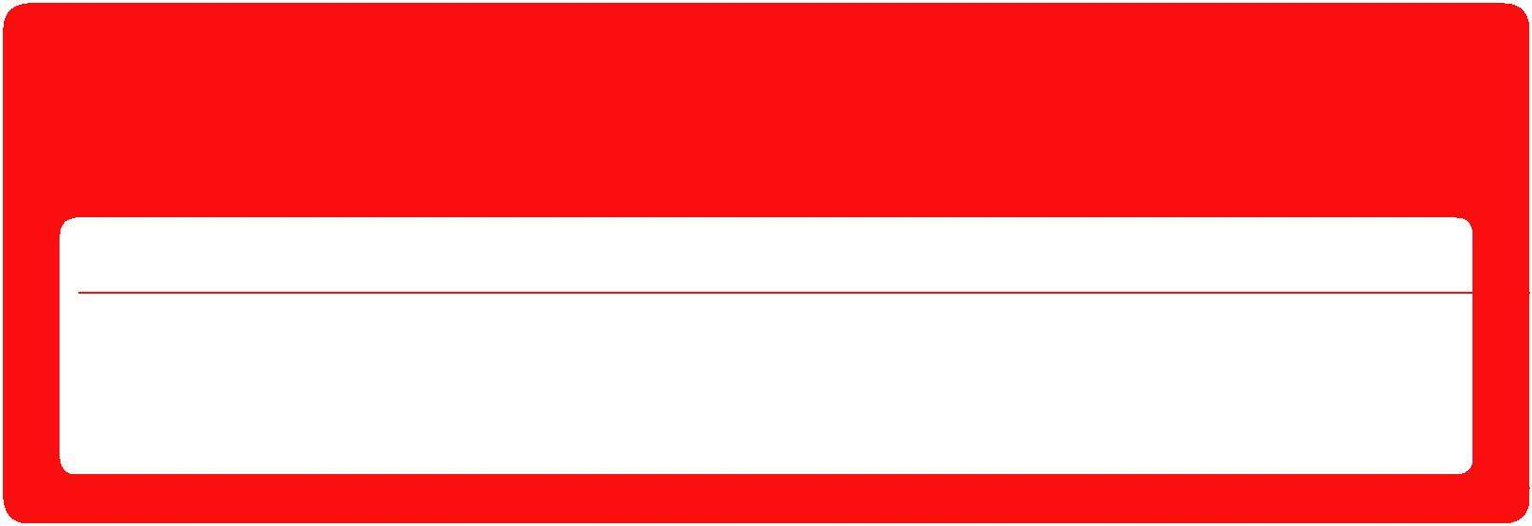
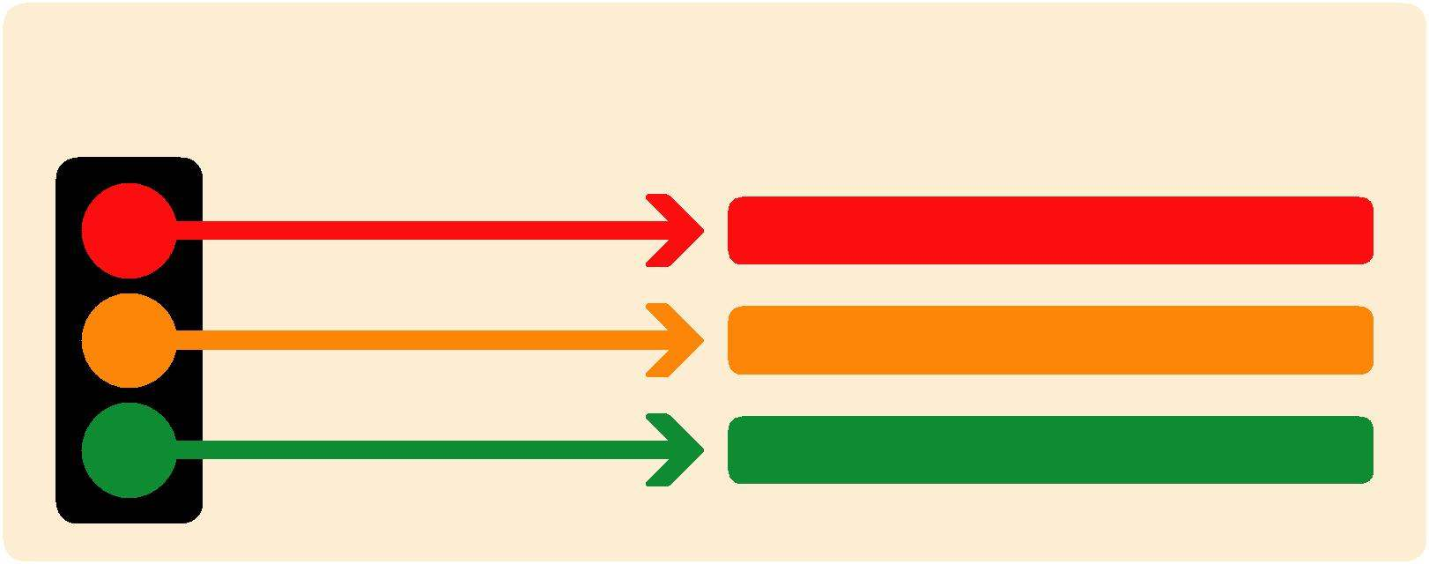
This passport belongs to me. Please return it when I am discharged.
Mental Capacity Act 2005
If I am a young person aged 16 or 17 and assessed as lacking the capacity to consent to my treatment, the following people must be involved in any decisions made in my best interest.
Name
Relationship
Contact details
Nursing and medical staff
please look at my passport before you do any interventions with me.
Things you must know about me
Things that are important to me
My likes and dislikes

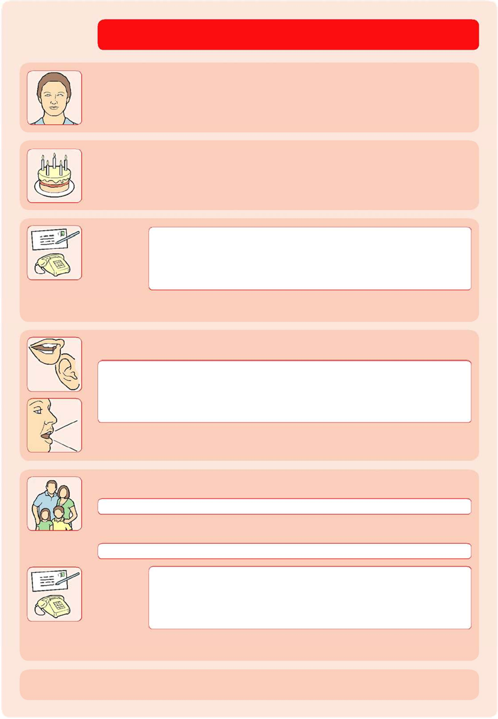
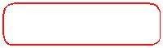
Name
Name:

I like to be known as: Identity:

Things you must know about me
Date of Birth:

Address:
Telephone number:
Preferred Language:

Hospital Number:

How I communicate (please circle):

Verbal Non-verbal
Family contact person:

Relationship – (mum, dad, support worker )

Address:

Telephone number:
Date By: Role:
completed:


Likes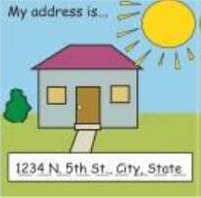S
Allergies:

NHS Number



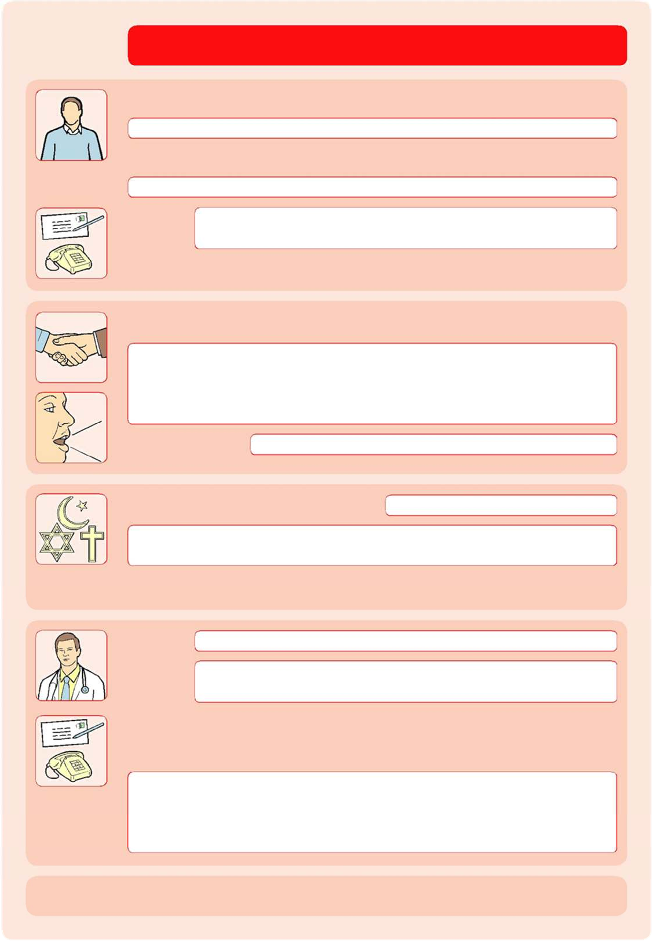
Child development service details:
Things you must know about me
Special Education Needs (SEN). Please indicate the type of SEN or
Learning disability:

SENCO details:
Telephone number:
School name and address:
Date By: Role:
completed:









Do you have an EHCP plan? YES / NO

Things that are important to me

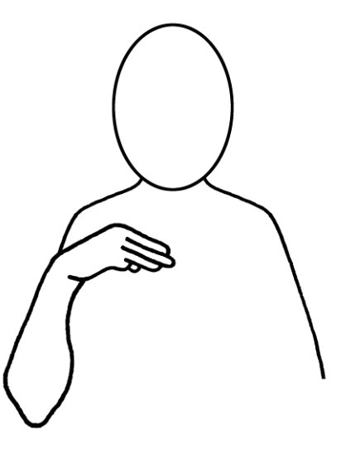

can we consider including something about not being in pain / hurting etc

Please use this space to share information about my general daily living.
For example:
Am I independent? Can I tell you when I need to go the toilet or when I need my pad changed?
Moving around (Include hoist, sling type/size, wheelchair and cushion, safety needs)
Breathing (Include tracheostomy tube size & make, CPAP/Bi-PAP/Ventilator settings, suction, oxygen) Do I need help with my breathing?
Do I have a sensory sensitivity to light, sound, smell, or touch?

About me

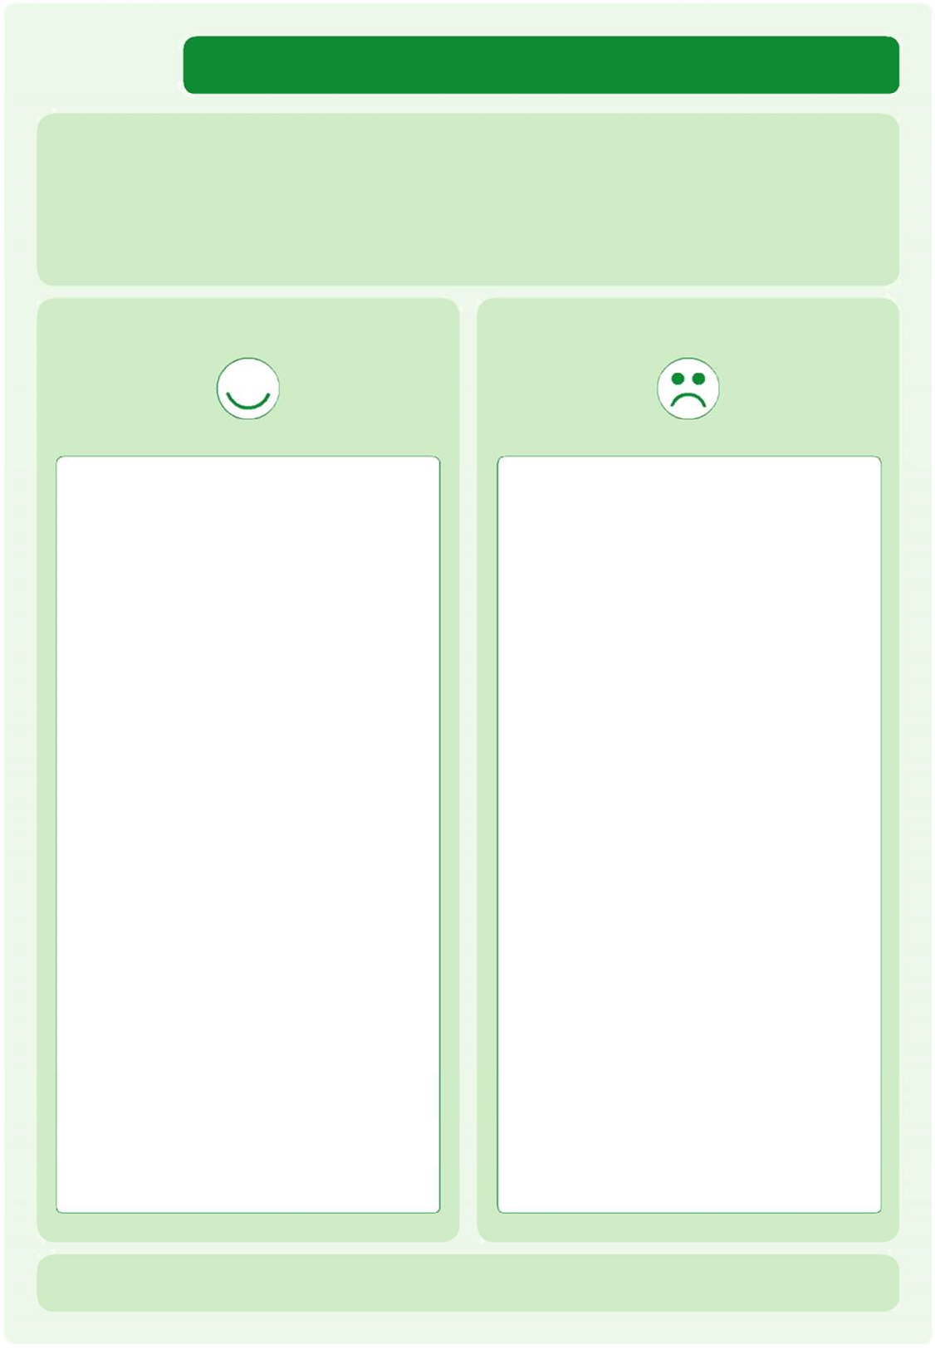
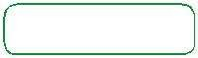

My likes, dislikes, and comfort conditions

Likes:
For example – what makes me happy, things I like to do, such as watching TV, reading, music, routines.
Dislikes:
for example – don’t shout, food I don’t like,
physical touch.

Things I like Things I don’t like
Please do this: Don’t do this:

Date By: Role:
Completed:

.

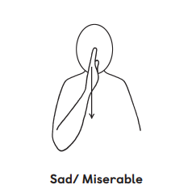
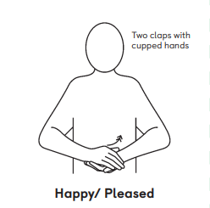

Information for staff

Information for Patients, Parents, and Carers

Date completed: B

